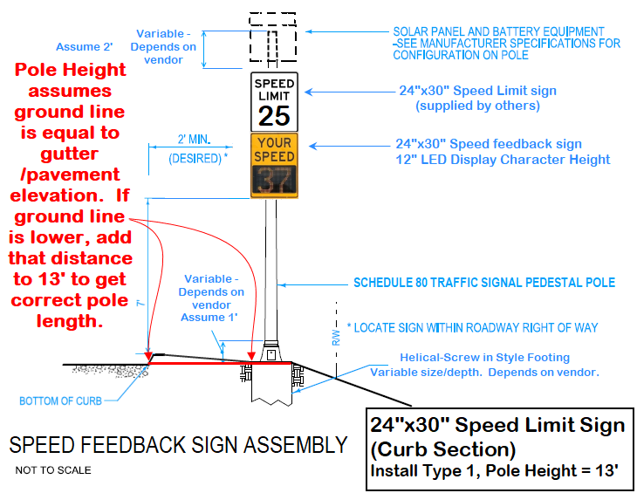

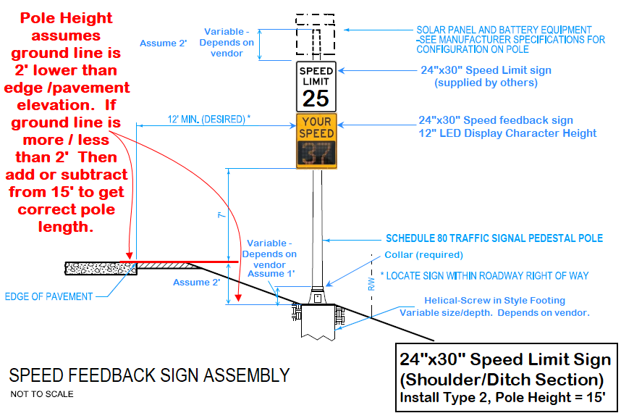

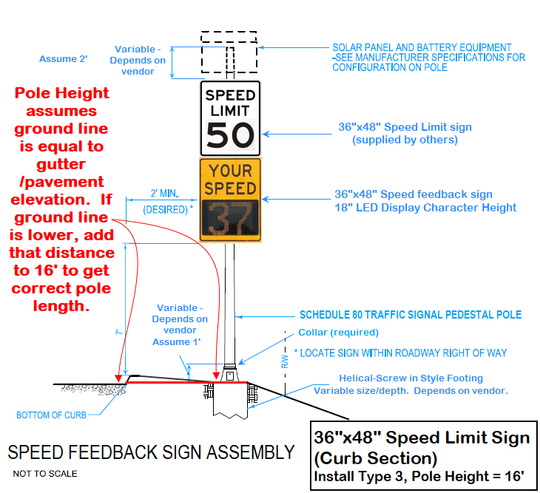

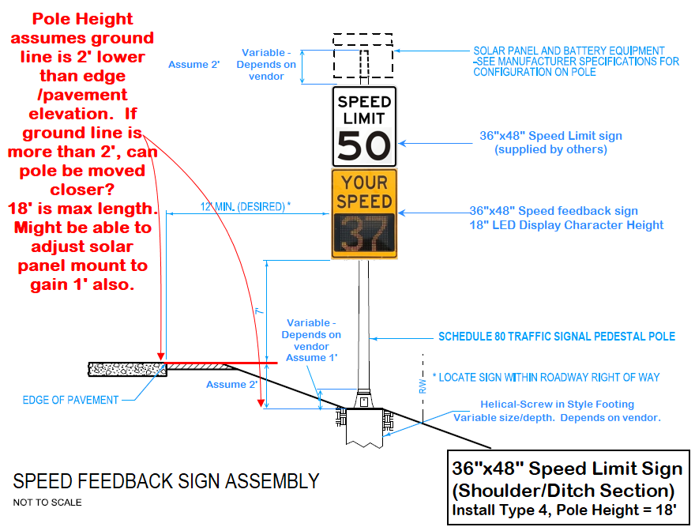

**Instructions on using cell phone to get coordinates:**

This can be done in the field, or in the office.

Open “Google Maps”.

Zoom to the location of the sign. (1st image)

Press you finger on the screen on top of the sign location to “Drop a Pin”. (2nd image) Get as exact as possible. We will be using these coordinates to:

Update the sign inventory.

Call for utility locates.

Place the sign if the lath gets lost.

Scroll down until you see the coordinates: (3rd image)

Tap the screen and select “Copy” (3rd image)

Open up an e-mail or text message

Tap the screen and select “Paste”. (4th image)

Send yourself the coordinates to so you can copy them into the form later.

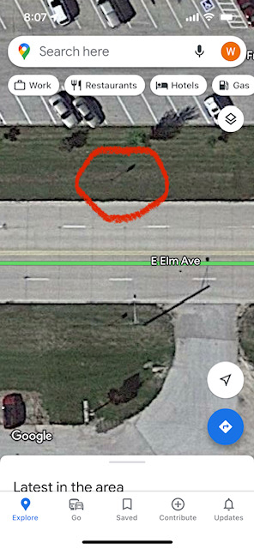 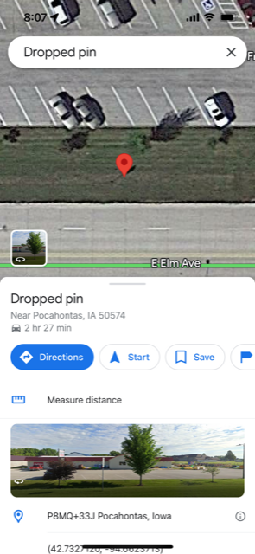 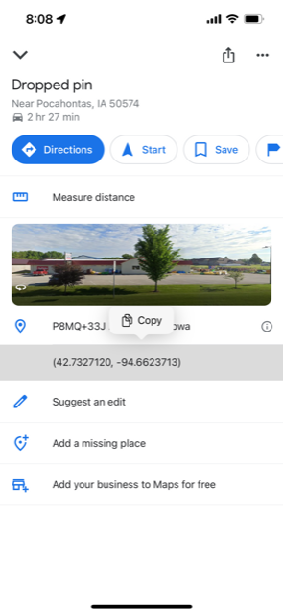 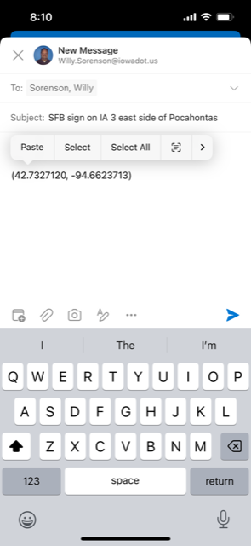

**How to Request a Pole be installed using Econolite’s “Smart Sheets” database entry system**

Create an account by clicking on link below and select “Create one” and/ contact Kelly King at [kking@econolite.com](mailto:kking@econolite.com) or (515)-238-3208

SmartSheet input Page: <https://app.smartsheet.com/b/home?dlp=%2Fdashboards%2FfJH3rJx6qcfGxCWG24F83gHvF5CJcfMPVg5QP4x1>

1) Log into “Smart Sheets”:

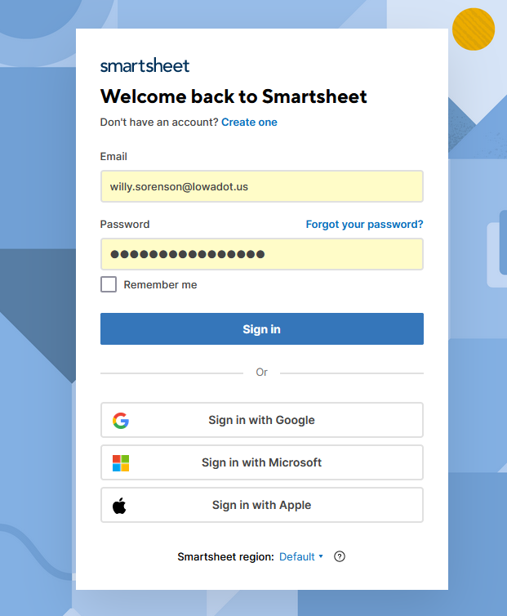

**2) Scroll down to “Work Order Request Form”**

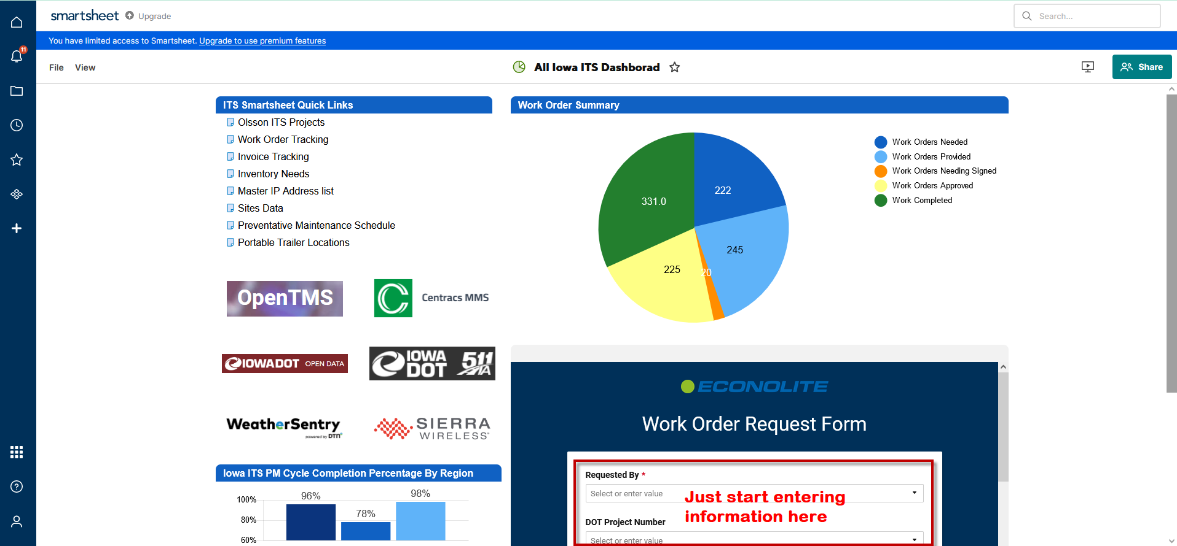

**3) Enter the information below:**

**Name: Start typing and your name will appear**

**Project # (SFB Signs will use): NHSN-000-T(275)- -2R-00**

**Work Order Title: Speed Feedback Sign Pole Installation for (insert town name(s))**

**Baker Electric Work Needed Check box: Check this. Baker will be doing this work.**

**Work Scope: Insert text something like “Install x poles…**

**Example used for Granger:**

Install:

18' pole at (IA 17 SB) at existing Speed limit sign location.

18' pole at (IA 17 NB) lath at existing Speed Limit sign location.

18' pole at (IA 141 WB) at existing speed limit sign location.

18' pole at (IA 141 EB) use existing speed limit sign, outside right shoulder.

See attachment for coordinates.

**Data Collection Abilities:**

**Traffic Logix (12” signs) come with a free 1 year SafePace Cloud Access. For details, check their web page:** [**https://trafficlogix.com/cloud-data-overview/**](https://trafficlogix.com/cloud-data-overview/)

**Part of the quote from Traffic Logix**

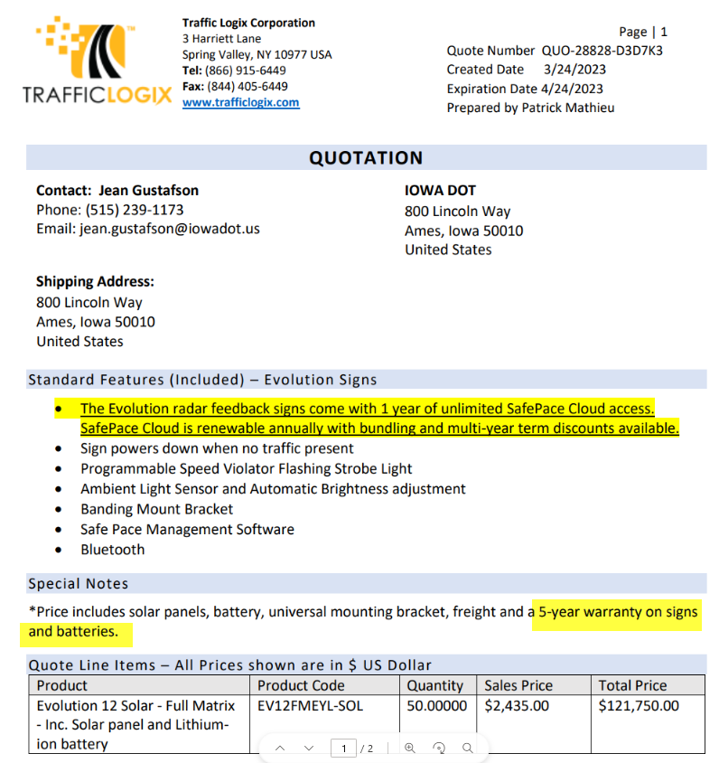

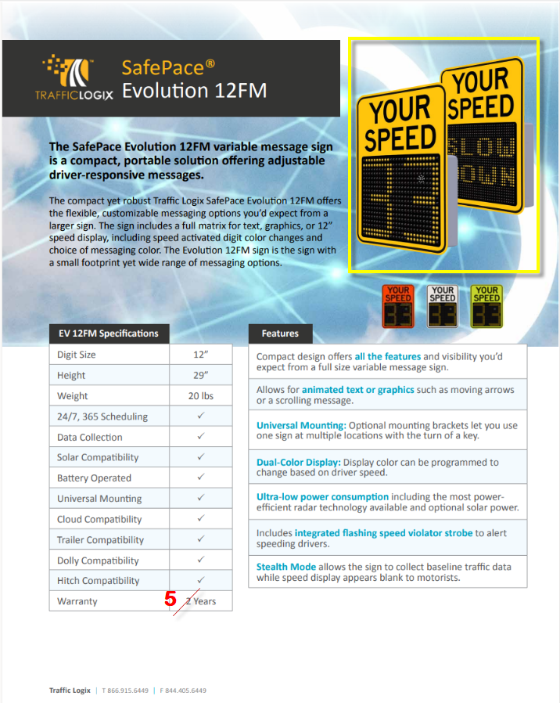

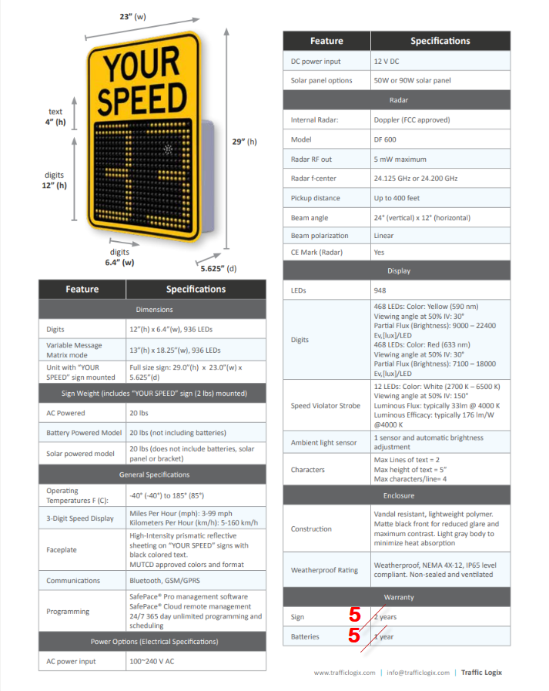

**Carmanah**





**Stalker**

