Template Version 1.0
May 2018

Interchange
Operations Report for
{Project Name}

{County, Iowa}

Project Number {IMN-XXX-X(XXX)XX—XX-XX}

Prepared for:

{Month Day, Year}

Instructions for Using Template
Use this template as a starting point for writing an Interchange Operations Report (IOR) related to an access change request. This template provides materials to be supplied in all IJRs and in the order in which the materials are to be presented. The user is encouraged to follow this template as strictly as possible to provide consistency for documentation. The Iowa Department of Transportation recognizes that every project is unique, and modifications to template materials and organization of materials may be necessary to meet the unique characteristics of a project. This template should be used in conjunction with the Iowa DOT User Guide for New or Revised Interchange Access. Sections 3.2 and 4.5 of the Iowa DOT User Guide for New or Revised Interchange Access provide guidance pertaining to the IOR.
The page layout in this template is generally 8 ½” x 11” portrait, and this should be maintained by the user. It may be appropriate to provide figures or tables on pages that are 11” x 17” landscape.
Text in this template is color-coded to identify user inputs, instructions and standard text, as follows:
- Text highlighted yellow is a user input. This text should be replaced with the appropriate text or value, and the highlight should be removed.
- Text in {brackets} is also a user input. This text is part of a heading or title, and the formatting of this text should not be altered. Text in {brackets} on the following title page is referenced to text on the cover page. This text should be updated by right-clicking on the text.
- Text in bold/orange is instructional to help the user complete the document. This text should be deleted from the document once the user has followed the instructions provided by this text.
- Text that is bold/red is a reference to a table or figure. This format should be used for all references to tables and figures.
- Text that is black or a hyperlink is standard text that should generally not be edited.
Example tables and figures are provided in this template. These tables and figures should be populated, replaced or deleted as appropriate. Table and figure title numbers are set up to reference the appropriate section of the document and the appropriate table or figure number within each section. The reference to tables and figures within the body of the document is cross-referenced to the table or figure title. When adding tables or figures, the user should match the formatting of provided tables and figures (including table/figure titles and references within the body). When adding or removing tables or figures, the provided table and figure title numbers and references within the body should be updated.
Page breaks are inserted at locations throughout the template for readability of the template. The user should remove page breaks where appropriate.
Double-click in the header and Word will automatically update the project name and date after filling out the cover page.
The lists for Contents, Tables and Figures on the following page(s) should be updated after completing the document.
This page is to be deleted prior to submittal.
{Project Name}
{County, Iowa}

Project Number
{IMN-XXX-X(XXX)XX—XX-XX}
This document has been prepared to obtain Iowa Department of Transportation or Federal Highway Administration approval for new or revised interchange access on the Interstate or State Highway System.
Interchange Operations Report
Prepared by
Agency or Company
For
The Iowa Department of Transportation and Federal Highway Administration
{Month Day, Year}
Replace Seal | I hereby certify that this engineering document was prepared by me or under my direct personal supervision and that I am a duly licensed Professional Engineer under the laws of the State of Iowa.  Add Signature MM/DD/YYYY  JOHN SMITH, P.E. (date)  License No. XXXXX  My license renewal date is December 31, YYYY  Pages of sheets covered by this seal:  List Pages

The request for new or revised interchange access on State highway facility at crossroad (mile marker) in County, Iowa is acceptable for engineering and operations.
MM/DD/YYYY
Division District Engineer (date)
Iowa Department of Transportation
The acceptance signature block for the Division District Engineer, shown above, is only needed for non-Interstate projects. For Interstate projects, remove the above acceptance signature block and use the letter of approval on the following page.

District X Office/Highway Division
Address l City, State Zip
Phone: XXX-XXX-XXXX l Email: Email@iowadot.us

For IORs on the Interstate System, following review and approval of the IOR by the Iowa DOT District Engineer, a letter of approval by the District Engineer for the IOR is sent via email to the FHWA, Iowa Division for approval. This email is sent to Iowa.FHWA@DOT.gov. Typically for this action, a ProjectWise link to the final IOR is sent to FHWA with this letter of approval attached to the email. Once the FHWA has approved the IOR, the FHWA will submit a letter of approval for the IOR. The letters of approval by the Iowa DOT and FHWA should be filed with the final IOR that is signed and approved.
This page should be used as a guide when preparing the Iowa DOT letter of approval. Remove this page from the IOR document that is submitted for reviews.
Month Day, Year

Program Delivery Team Leader
FHWA, Iowa Division
105 6th Street
Ames, Iowa 50010

Subject: Project Name Interchange Operations Report
Project Number IMN-XXX-X(XXX)XX—XX-XX

Dear Program Delivery Team Leader,

I have approved this Interchange Operations Report, dated Month Day, Year for Engineering Operations and I am submitting it to FHWA for approval.

Sincerely,

Add Signature

Name
District X Engineer

Contents
1 Introduction 1
2 Project Background 1
2.1 Project Location and Existing Conditions 1
2.2 Project History 3
2.3 Proposed Improvements 4
3 Traffic Operations 4
3.1 Methodology 4
3.1.1 Traffic Forecasting Methodologies 5
3.1.2 Software Input Assumptions and Methodologies 6
3.1.3 Performance Measures 6
3.2 Existing Conditions Analysis 7
3.2.1 Existing Traffic Volumes 7
3.2.2 Existing Conditions Operational Analysis 7
3.3 Design Year 20XX No-Build Conditions Analysis 10
3.3.1 Design Year 20XX No-Build Conditions Traffic Forecasts 10
3.3.2 Design Year 20XX No-Build Conditions Operational Analysis 10
3.4 Design Year 20XX Build Conditions Analysis 11
3.4.1 Design Year 20XX Build Conditions Traffic Forecasts 11
3.4.2 Design Year 20XX Build Conditions Operational Analysis 12
3.5 Opening Year 20XX Build Conditions Analysis 12
4 Safety 13
4.1 Methodology 13
4.2 Existing Crash Analysis 14
4.3 Predictive Crash Analysis 16
5 Conclusions 16
5.1 Conclusions 17
5.2 Recommendations 17
6 Appendix 17

Tables
Table 3-1. Freeway LOS Density Thresholds 6
Table 3-2. Intersection LOS Delay Thresholds 7
Table 3-3. Existing Conditions Freeway Operations 8
Table 3-4. Daily Volume Comparison between Existing and Design Year Conditions 11
Table 4-1. Existing Conditions Mainline Segment Crash Rates 14
Table 4-2. Manner of Crash for Mainline Crashes 15
Table 4-3. Cause of Crash for Mainline Crashes 15
Table 4-4: Predictive Crash Alternative Comparison 16

Figures
Figure 2-1. Project Location Map 2
Figure 3-1. Area of Influence 4
Figure 3-2. Existing Conditions Traffic Volumes 7
Figure 3-3. Existing Conditions Operations 9
Figure 3-4. Design Year 20XX No-Build Conditions Traffic Forecasts 10
Figure 3-5. Opening Year 20XX Build Conditions Traffic Forecasts 13

This page is intentionally left blank.

Introduction
This Interchange Operations Report (IOR) provides the operational and safety evaluations, and conclusions to justify new or revised access on Interstate or State highway facility at crossroad (mile marker) in County, Iowa. The proposed access change would describe the changes that would be made by the proposed access change. The access change request is being made to state the goals and objectives of the proposed access change. The engineering and operations documented in this IOR are provided through operational and safety evaluations, conclusions, and recommendations.

Project Background

Project Location and Existing Conditions
The project is located describe the location in relation to surrounding communities and the project facilities. Example of project location description for example graphic provided in Figure 2.1 below: The project is located at the I-80 / 1st Avenue interchange in eastern Coralville, Iowa, immediately west of the Iowa River. The location of the project is shown in For projects where a new interchange or major modifications to an existing interchange are proposed, provide additional description of the project and surrounding features that have influence on one another. This may include a list of the intersections or interchanges immediately adjacent to the project. This should also include description of predominant land use types surrounding the project. An example outline of adjacent intersections or interchanges and land use description is provided below. For projects with minor improvements to an existing interchange, delete the example text below.
Intersections or interchanges immediately adjacent to the project include:
- I-80 / Coral Ridge Avenue interchange west of the project.
- I-80 / Dubuque Street interchange east of the project.
- 1st Avenue / E 9th Street intersection south of the project.
- 1st Avenue / Russell Slade Boulevard intersection north of the project.
The land uses surrounding I-80 at 1st Avenue (mile marker 242) are a mix of commercial, industrial and residential uses.
Figure 2-1 in relation to surrounding communities and facilities.
For projects where a new interchange or major modifications to an existing interchange are proposed, provide additional description of the project and surrounding features that have influence on one another. This may include a list of the intersections or interchanges immediately adjacent to the project. This should also include description of predominant land use types surrounding the project. An example outline of adjacent intersections or interchanges and land use description is provided below. For projects with minor improvements to an existing interchange, delete the example text below.
Intersections or interchanges immediately adjacent to the project include:
- I-80 / Coral Ridge Avenue interchange west of the project.
- I-80 / Dubuque Street interchange east of the project.
- 1st Avenue / E 9th Street intersection south of the project.
- 1st Avenue / Russell Slade Boulevard intersection north of the project.
The land uses surrounding I-80 at 1st Avenue (mile marker 242) are a mix of commercial, industrial and residential uses.
Figure 2-1. Project Location Map
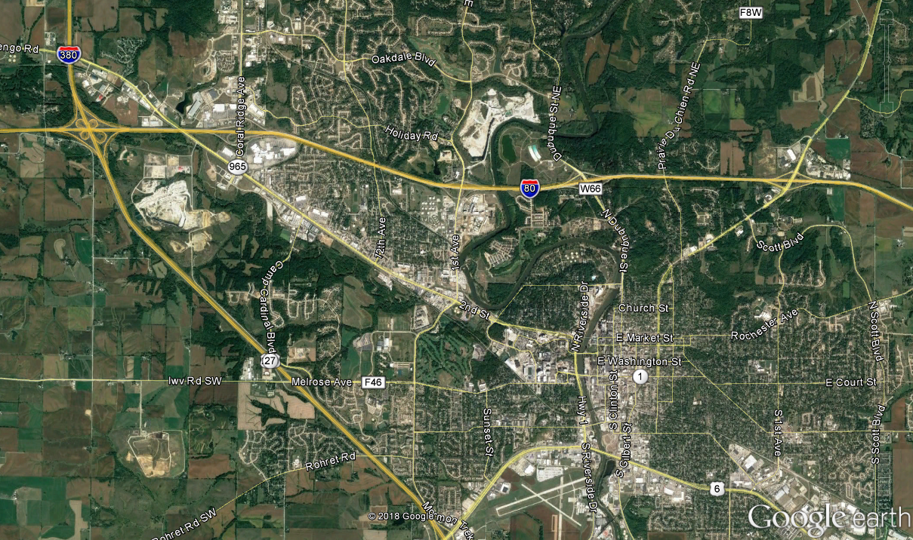
Iowa City
Coralville
Oakdale
Project Location
N
(Replace this example graphic with project location graphic)
The figure used to show the project location should include an area of sufficient size to identify the project area in relation to surrounding communities and nearby features or facilities.
Description of existing roadway network.
List geometric features, safety features or facilities that are relevant to the project goals and objectives. The discussion of existing roadway network should typically be limited to one or two paragraphs. Provide graphics such as maps or photos to illustrate geometric features as appropriate.

Project History
Project history.
Provide a brief history of the project, including past studies or improvements that may have led to the proposed access change. Reference local, regional and statewide planning documents that include the project and funding sources identified. For projects on the Interstate System that are not in a planning document, describe the steps being taken to have the project added in local/regional/state planning documents.

Proposed Improvements
Description of proposed improvements.
Briefly describe the purpose of the project, stating the goals and objectives to be achieved by the proposed access change.

Traffic Operations

Methodology
The area of influence for operational analysis is shown in Figure 3-1. The area of influence includes freeway mainline, ramps, ramp terminal intersections and crossroad intersections within the boundaries shown in Figure 3-1.
Figure 3-1. Area of Influence
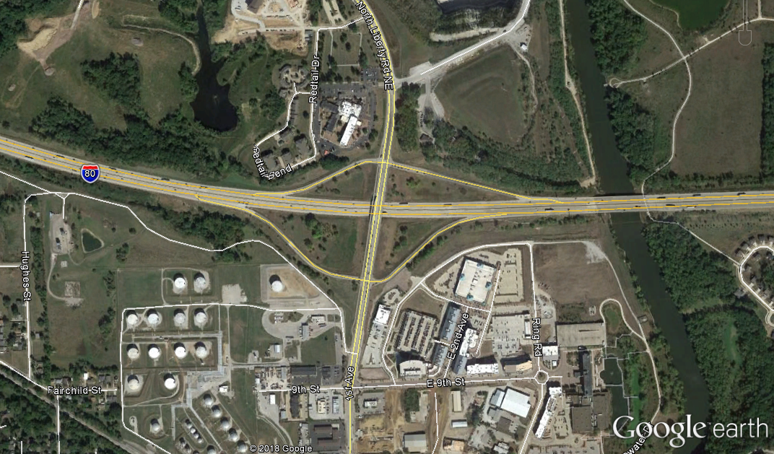
Area of Influence
N
(Replace this example graphic with project area of influence graphic)

The following analysis years/scenarios were evaluated for traffic operational analysis:
- Existing (base) year 20XX.
- Design year 20XX No-Build.
- Design year 20XX Build Alternative Name. Provide a separate bullet for each Alternative evaluated for the design year. Provide additional description for each Alternative as needed to differentiate between the Alternatives.
- Opening year 20XX Build Alternative Name. Remove this bullet if not included for the traffic operational analysis.
Operational analysis was completed for periods of each scenario. (e.g., AM and PM peak hours). It may be necessary or beneficial to show existing data to support determination of the period durations, such as ATR or INRIX speed data.
Operational analysis of locations within the area of influence was completed using list software and software version used for the operational analysis for the scenarios/periods outlined above. Provide a description of the software as appropriate. (Examples: HCS 7 is a computerized analytical tool that replicates the operational analysis procedures of the Highway Capacity Manual, 6th Edition. Vissim is a microscopic simulation (microsimulation) software that models individual vehicles and their behavior based on algorithms for specific driving tasks such as car following and lane changing.)

Traffic Forecasting Methodologies
Existing conditions traffic volumes were developed from traffic counts, vehicle classification data and origin-destination data obtained for this project. Existing conditions traffic data was obtained from state the sources and methodologies for obtaining existing conditions data. Modify or add to the methodology for developing existing conditions traffic volumes as appropriate.
Traffic forecasts for design year No-Build and Build conditions, and opening year Build conditions were provided by source. Forecasts were based on state the Travel Demand Model(s) to be used and the horizon year for the Travel Demand Model(s), and utilized existing turning patterns, vehicle classification data and origin-destination data as appropriate. Modify or add to the methodology for developing design year and opening year forecasts as appropriate.

Software Input Assumptions and Methodologies
Data, forecasts and conceptual layouts were used for inputs of geometry, traffic control, traffic volumes and travel speeds.
Provide additional details to summarize the software input assumptions and methodologies as appropriate. Reference a project Methods and Assumptions (M&A) document in the appendix if one was completed for the project. If an M&A document is not created for the project, the user is encouraged to review the Iowa DOT User Guide for New or Revised Interchange Access and Iowa DOT Methods and Assumptions Template for guidance on documenting software input assumptions and methodologies.

Performance Measures
Summarize the performance measures used to report operational analysis results.
Level of service (LOS) is typically the primary performance measure reported from the operational analysis in an IOR. Provide a description of LOS and the freeway density / intersection delay thresholds for LOS. Example tables for LOS thresholds are provided below.
LOS thresholds for freeways are summarized in Table 3-1. LOS thresholds for intersections are summarized in Table 3-2.
Table 3-1. Freeway LOS Density Thresholds
Level of Service (LOS) | Freeway Segment Density (pc/mi/ln¹)
 | Basic Freeway and Multilane Highway Segment | Ramp Junction Area | Weave Segment
A | 0-11 | ≤ 10 | ≤ 10
B | >11-18 | >10-20 | >10-20
C | >18-26 | >20-28 | >20-28
D | >26-35 | >28-35 | >28-35
E | >35-45 | >35 | >35-43
F | >45 | Demand Exceeds Capacity | >43, or Demand Exceeds Capacity
Source: Highway Capacity Manual, 6th Edition.
¹ Passenger cars per mile per lane.

Table 3-2. Intersection LOS Delay Thresholds
Level of Service (LOS) | Control Delay (seconds/vehicle)
 | Signalized Intersection | Unsignalized Intersection
A | ≤ 10 | ≤ 10
B | >10-20 | >10-15
C | >20-35 | >15-25
D | >35-55 | >25-35
E | >55-80 | >35-50
F | >80 or V/C > 1.00 | >50 or V/C > 1.00
Source: Highway Capacity Manual, 6th Edition.

Existing Conditions Analysis

Existing Traffic Volumes
The existing (year 20XX) traffic volumes within the area of influence are provided in Figure 3-2.
Provide additional details to describe the existing traffic volumes within the area of influence as appropriate. If existing conditions operational analysis results are displayed on a figure that also illustrates existing traffic volumes, it may be appropriate to consolidate materials from this section with the Existing Operational Analysis section (a separate figure for existing conditions traffic volumes may then not be necessary).
If existing traffic volumes details and existing conditions operational analysis results are consolidated, remove subsection headings under the Existing Conditions Analysis section heading.
Figure 3-2. Existing Conditions Traffic Volumes
Insert graphic for existing conditions traffic volumes
Provide a figure that shows existing traffic volumes throughout the area of influence, including daily volumes, peak hour/period movement volumes, weaving volumes and truck percentages as appropriate. It may be necessary to provide this figure as a standalone page depending on the size of the area of influence.

Existing Conditions Operational Analysis
Operational analysis was performed for existing (year 20XX) conditions for the state the periods (e.g., AM and PM peak hours) to determine the current operations within the area of influence. The results for existing conditions operational analysis are shown in list tables and figures. Duplicate the previous sentence if more than one tool is used for the operational analysis and specify the tool for each series of tables/figures.
Provide tables and/or figures to report results of the existing conditions operational analysis as appropriate. An example table and figure is provided below to illustrate example formatting (these examples are not meant to provide a full summary of what should be provided). Provide a summary of the results in paragraphs or bullets to supplement tables and figures, highlighting the overall operations within the area of influence, and noting locations with poor operations or other operational concerns.
Table 3-3. Existing Conditions Freeway Operations
(Specify software in table title if using more than one software tool)
Location | Segment Type | Density (pc/mi/ln) / LOS
 |  | AM Peak Hour | PM Peak Hour
I-80 Eastbound
At Coral Ridge Ave NB Entry | Ramp Junction | 17.4 / B | 19.3 / B
Coral Ridge Ave to 1st Ave | Basic Freeway | 16.3 / B | 17.7 / B
At 1st Ave Exit | Ramp Junction | 21.8 / C | 23.6 / C
1st Ave Exit to Entry | Basic Freeway | 14.1 / B | 14.6 / B
1st Ave to Dubuque Street | Weave | 16.7 / B | 17.4 / B
I-80 Westbound
Dubuque Street to 1st Ave | Weave | 12.3 / B | 15.9 / B
1st Ave Exit to Entry | Basic Freeway | 11.1 / B | 12.9 / B
At 1st Ave Entry | Ramp Junction | 15.8 / B | 17.2 / B
1st Ave to Coral Ridge Ave | Basic Freeway | 15.2 / B | 16.6 / B
At Coral Ridge Ave Exit | Ramp Junction | 17.1 / B | 23.9 / C
Source: HCS 7 Analysis, Agency or Company that conducted the analysis, Date.
(Remove or modify the table above as appropriate)

Figure 3-3. Existing Conditions Operations
(Specify software in figure title if using more than one software tool)
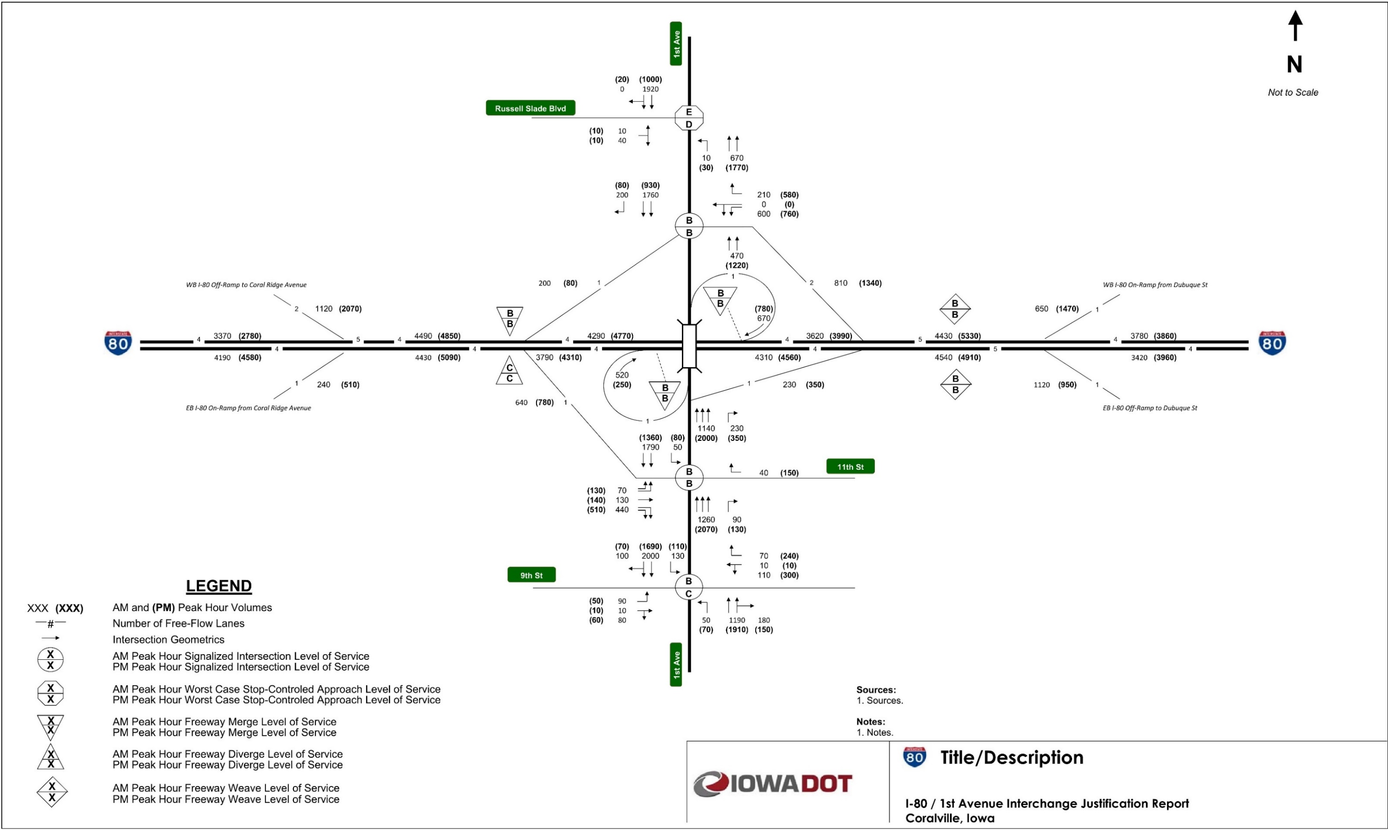
(Replace or delete the above figure as appropriate)

Design Year 20XX No-Build Conditions Analysis
A summary of future year No-Build conditions are provided in the following sections. The future year No-Build conditions consist of future year traffic volumes on existing geometry plus adjacent planned roadway improvements.
Provide a description of No-Build conditions, including planned roadway and interchange improvements adjacent to the proposed access change that are likely to have an influence on traffic patterns within the area of influence. For these planned improvements, describe the status of these projects. Provide a figure (or figures) to show the locations of planned improvements as appropriate.

Design Year 20XX No-Build Conditions Traffic Forecasts
Future year No-Build conditions were evaluated for the project design year 20XX. The design year 20XX No-Build conditions traffic forecasts within the area of influence are provided in Figure 3-4.
Provide additional details to describe the design year No-Build conditions traffic forecasts within the area of influence as appropriate. If design year No-Build conditions operational analysis results are displayed on a figure that also illustrates design year No-Build conditions traffic forecasts, it may be appropriate to consolidate materials from this section with the Design Year No-Build Conditions Operational Analysis section (a separate figure for design year No-Build conditions traffic forecasts may then not be necessary).
If design year No-Build conditions traffic forecasts details and design year No-Build conditions operational analysis results are consolidated, remove subsection headings under the Design Year 20XX No-Build Conditions Analysis section heading.
Figure 3-4. Design Year 20XX No-Build Conditions Traffic Forecasts
Insert graphic for future year No-Build conditions traffic forecasts
Provide a figure that shows design year No-Build conditions traffic forecasts throughout the area of influence, including daily volumes, peak hour/period movement volumes, weaving volumes and truck percentages as appropriate. It may be necessary to provide this figure as a standalone page depending on the size of the area of influence.

Design Year 20XX No-Build Conditions Operational Analysis
Operational analysis was performed for design year 20XX No-Build conditions for the state the periods (e.g., AM and PM peak hours) to determine the expected future operations within the area of influence without the proposed access change. The results for design year 20XX No-Build conditions operational analysis are shown in list tables and figures. Duplicate the previous sentence if more than one tool is used for the operational analysis and specify the tool for each series of tables/figures.
Provide tables and/or figures to report results of the design year No-Build conditions operational analysis as appropriate. Formatting of these tables and figures should match those used to report results for the existing conditions. Provide a summary of the results in paragraphs or bullets to supplement tables and figures, highlighting the overall operations within the area of influence, and noting locations with poor operations or other operational concerns.

Design Year 20XX Build Conditions Analysis

Design Year 20XX Build Conditions Traffic Forecasts
Design year Build conditions traffic forecasts.
For projects where the design year Build conditions traffic forecasts are the same as the design year No-Build conditions traffic forecasts, provide a statement that they are the same, and provide any additional narrative to document why they are the same.
For projects where the design year Build conditions traffic forecasts are different from the design year No-Build conditions traffic forecasts, provide comparison of the Build conditions forecasts to No-Build conditions forecasts and existing volumes. The comparison of traffic forecasts should be provided via table(s) and narrative as appropriate. A sample table for comparing traffic forecasts is provided below.
Table 3-4. Daily Volume Comparison between Existing and Design Year Conditions
Location | Daily Traffic Volumes
 | Existing | Design Year 20XX No-Build | Design Year 20XX Build
Interstate mainline location 1 | XX,XXX | XX,XXX | XX,XXX
Interstate mainline location 2 | XX,XXX | XX,XXX | XX,XXX
Interstate mainline location 3 | XX,XXX | XX,XXX | XX,XXX
Interstate mainline location 4 | XX,XXX | XX,XXX | XX,XXX
Crossroad A north of Interstate | XX,XXX | XX,XXX | XX,XXX
Crossroad A south of Interstate | XX,XXX | XX,XXX | XX,XXX
Crossroad B north of Interstate | XX,XXX | XX,XXX | XX,XXX
Crossroad B south of Interstate | XX,XXX | XX,XXX | XX,XXX
Crossroad C north of Interstate | XX,XXX | XX,XXX | XX,XXX
Crossroad C south of Interstate | XX,XXX | XX,XXX | XX,XXX
Source: Source, Date.
For projects where the design year Build conditions traffic forecasts are different from the design year No-Build conditions traffic forecasts, provide a figure to illustrate design year Build conditions traffic forecasts within the area of influence (similar to those provided for the existing volumes and design year No-Build conditions forecasts). Provide additional details to describe the design year Build conditions traffic forecasts within the area of influence as appropriate. It may be necessary to provide multiple figures if multiple Build alternatives were evaluated. If design year Build conditions operational analysis results are displayed on a figure that also illustrates design year Build conditions traffic forecasts, it may be appropriate to consolidate materials from this section with the Design Year Build Conditions Operational Analysis section (a separate figure for design year Build conditions traffic forecasts may then not be necessary).
If design year Build conditions traffic forecasts details and design year Build conditions operational analysis results are consolidated, remove subsection headings under the Design Year 20XX No-Build Conditions Analysis section heading.

Design Year 20XX Build Conditions Operational Analysis
Operational analysis was performed for design year 20XX Build conditions for the periods (e.g., AM and PM peak hours) to determine the expected future operations within the area of influence with the proposed access change. The results for design year 20XX Build conditions operational analysis are shown in list tables and figures. Modify or duplicate the previous sentence to account for projects that include analysis with more than one tool and/or have multiple Build alternatives and specify the tool for each series of tables/figures.
Provide tables and/or figures to report results of the design year Build conditions operational analysis as appropriate. Formatting of these tables and figures should match those used to report results for the existing conditions and design year No-Build conditions. Provide a summary of the results in paragraphs or bullets to supplement tables and figures, highlighting the overall operations within the area of influence, and noting locations with poor operations or other operational concerns.

Opening Year 20XX Build Conditions Analysis
This section is only applicable for projects that include an opening year analysis. For projects that do not include an opening year analysis, delete this section (including the section heading).
The expected opening year for the proposed access change is year 20XX. Traffic forecasts developed for opening year conditions of the preferred Build alternative are provided in Figure 3-5.
Provide additional details to describe the opening year Build conditions traffic forecasts within the area of influence as appropriate. If opening year Build conditions operational analysis results are displayed on a figure that also illustrates opening year Build conditions traffic forecasts, it may be appropriate to mention that the forecasts are provided on a figure in conjunction with the opening year Build conditions operational analysis results.
Figure 3-5. Opening Year 20XX Build Conditions Traffic Forecasts
Insert graphic for opening year Build conditions traffic forecasts
Provide a figure to illustrate opening year Build conditions traffic forecasts within the area of influence (similar to forecast figures used for other scenarios). Delete this figure if opening year Build conditions traffic forecasts are provided on a figure in conjunction with the opening year Build conditions operational analysis results.
Operational analysis was performed for opening year 20XX Build conditions for the periods (e.g., AM and PM peak hours) to determine the expected operations within the area of influence during the first year of operations with the proposed access change. The results for opening year 20XX Build conditions operational analysis are shown in list tables and figures. Duplicate the previous sentence if more than one tool is used for the operational analysis and specify the tool for each series of tables/figures.
Provide tables and/or figures to report results of the opening year Build conditions operational analysis as appropriate. Formatting of these tables and figures should match those used to report operational results for other scenarios. Provide a summary of the results in paragraphs or bullets to supplement tables and figures, highlighting the overall operations within the area of influence, and noting locations with poor operations or other operational concerns.

Safety

Methodology
The area of influence used for the safety analysis is the same as that used for the operational analysis (illustrated in Figure 3-1).
The following scenarios were evaluated for the traffic safety analysis:
- Existing crash analysis for the most recent number of years years of crash data (years 20XX-20XX). Number of years is typically a minimum of five years.
- Predictive crash analysis for design year 20XX No-Build. Remove this bullet if not included for the traffic safety analysis (No-Build predictive crash analysis may only be necessary when comparing predicted crashes to Build alternatives).
- Predictive crash analysis for design year 20XX Build Alternative Name. Provide a separate bullet for each Alternative evaluated for the design year.

Existing Crash Analysis
Existing crash analysis was performed to determine current crash trends and/or concerns within the area of influence. Existing crash analysis was performed for Interstate or State highway facility mainline segments and intersections within the area of influence. Crashes were analyzed for the five-year period 20XX-20XX, using the crash data obtained from source.
Provide a summary of overall crashes within the area of influence, noting the number of total crashes and those resulting in injuries or fatalities.
A summary of mainline segment total crashes and crash rates for the study period is provided in Table 4-1.
Table 4-1. Existing Conditions Mainline Segment Crash Rates
Location | Length  (miles) | ADT¹ | Number of Crashes (20XX-20XX) | Crashes/  100 MVM² | Statewide Average Crashes/100 MVM³
I-80 Eastbound
Coral Ridge Ave to 1st Ave | 1.78 | 26,400 | 54 | 62.97 | 100
1st Ave Exit to Entry | 0.47 | 21,600 | 10 | 53.97 | 100
1st Ave to Dubuque Street | 0.83 | 27,900 | 38 | 89.92 | 100
I-80 Westbound
1st Ave to Dubuque Street | 0.58 | 28,300 | 34 | 113.50 | 100
1st Ave Exit to Entry | 0.47 | 22,000 | 11 | 58.29 | 100
Coral Ridge Ave to 1st Ave | 1.80 | 26,500 | 63 | 73.37 | 100
Source: Agency or Company that conducted the analysis, based on crash data within the project area of influence from 20XX-20XX provided by source, Date.
¹ Year 20XX Annual Daily Traffic, Source, Date.
² MVM – Million Vehicle Miles. Cells highlighted pink indicate calculated crash rate exceeding the statewide average.
³ Iowa DOT Office of Traffic and Safety, Date, Crash Rates and Crash Densities in Iowa by Road System 20XX-20XX (State the range of years for the averages, such as: 5-year Averages: 2012-2016, and state the category, such as: Municipal Interstate).
(Modify the table above as appropriate)
Provide additional narrative to summarize the comparison of calculated crash rates to statewide averages as appropriate.
A summary of the manner of crash for mainline segments within the area of influence is provided in Table 4-2. A summary of the cause of mainline segment crashes within the area of influence is provided in Table 4-3.

Table 4-2. Manner of Crash for Mainline Crashes
Manner of Crash | Number of Crashes
Rear-end | 46
Sideswipe - same direction | 51
Broadside | 1
Angle - oncoming left turn | 1
Head-on | 1
Not reported | 11
Non-collision | 95
Unknown | 4
Total Crashes | 210
Source: Agency or Company that conducted the analysis, based on crash data within the project area of influence from 20XX-20XX provided by source, Date.
(Modify the table above as appropriate)
Table 4-3. Cause of Crash for Mainline Crashes
Cause of Crash | Number of Crashes
Animal | 18
Operating vehicle in an erratic/reckless/careless/negligent/aggressive manner | 7
Lost control | 15
Driving too fast for conditions | 47
Followed too close | 17
Swerving/evasive action | 33
Ran off road – right | 21
FTYROW: Other (explain in narrative) | 23
Other (explain in narrative): Other improper action | 15
Other (explain in narrative): No improper action | 9
Unknown | 5
Total Crashes | 210
Source: Agency or Company that conducted the analysis, based on crash data within the project area of influence from 20XX-20XX provided by source, Date.
(Modify the table above as appropriate)
Provide additional narrative to summarize the manner of crash and cause of crash results as appropriate.
Create additional tables and narrative as needed, such as those needed to summarize intersections within the area of influence. Provide a summary of any crashes resulting in a fatality. It may also be appropriate to provide a summary of crashes resulting in serious injury. Provide any additional details regarding the existing crash analysis as it relates to the project goals and objectives.

Predictive Crash Analysis
Design year 20XX predictive crash analysis was performed to determine the expected change to crashes within the area of influence resulting from the proposed access change. Predictive crash analysis was completed using state the method or tool used. The analysis was performed for state locations within the area of influence (e.g., Interstate mainline segments, ramps and ramp terminal intersections) within the area of influence.
Provide a summary of the expected change to crashes resulting from the proposed access change. It may be appropriate to provide tables and/or figures to illustrate these results. An example table for reporting the results of predictive crash analysis is provided below. Additional reporting examples are provided in the Iowa DOT Data Driven Safety Guidance document.
Table 4-4: Predictive Crash Alternative Comparison
Segment ID | Design Year 20XX Predicted Crashes¹
 | No Build |  | Build Alternative 1 |  | Build Alternative 2
 | Total Crashes | Crashes/100 MVM | Total Crashes | Crashes/100 MVM | Total Crashes | Crashes/100 MVM
Seg 1 | 10.4 | 88 | 10.1 | 70 | 10.5 | 68
Seg 2 | 9.3 | 67 | 9.2 | 53 | 9.8 | 50
Seg 3 | 9.1 | 66 | 8.8 | 51 | 8.8 | 51
Seg 4 | 8.5 | 70 | 11.2 | 74 | 11.2 | 74
Seg 5 | 2.9 | 62 | 2.6 | 54 | 3.2 | 50
Source: Tool, Agency or Company that conducted the analysis, Date
¹ Green highlighted cells indicate predicted crash frequency or rate for a Build alternative below the predicted frequency/rate for the No Build alternative. Pink highlighted cells indicate predicted crash frequency or rate for a Build alternative above the predicted frequency/rate for the No Build alternative.

Conclusions
The reviews and evaluations completed for this IOR are summarized below. A final recommendation for the proposed access change is provided based on the evaluations and conclusions documented in this IOR.

Conclusions
Summary of existing, No-Build and Build conditions.
Provide a summary of the traffic forecasts, operational analysis and safety analysis completed for existing, No-Build and Build conditions. This summary is typically on the order of one to three paragraphs.
For projects that include multiple Build alternatives, provide a comparison of evaluation results for each Build alternative used to select a preferred alternative. This evaluation comparison may include operations, safety, cost, impacts, constructability, multi-modal accommodations, stakeholder/public support, etc.

Recommendations
Provide recommendations for the proposed access change based on the evaluations and conclusions documented in the IJR. A sample recommendation is provided below.
Based on the evaluations and conclusions documented in this IOR, it is recommended to modify the existing diamond interchange on I-80 at XX Street in XXXXX County, Iowa to add a second southbound left-turn lane for the eastbound I-80 ramp terminal intersection, as illustrated earlier in this report. It is recommended that the XX Street bridge widening occur on the west side of the bridge to maintain the vertical clearance over I-80 on the east side of the bridge.

Appendix
List of appendix items.
Provide a list of items included in the appendix. It may be appropriate to include items in a digital appendix. Typical appendix items include:
- Design criteria worksheets
- Crash data
- Operational analysis output files
- M&A document

