IOWA DEPARTMENT OF NATURAL RESOURCES NPDES PERMIT APPLICATION

FORM 1 FOR INDUSTRIAL FACILITIES

|  |  |  |  |  |  |  |  |  |  |  |  |  |  |  |  |  |  |  |  |  |
| --- | --- | --- | --- | --- | --- | --- | --- | --- | --- | --- | --- | --- | --- | --- | --- | --- | --- | --- | --- | --- |
| FORM 1 – GENERAL INFORMATION | | | | | | | | | | | | | | | | | | | | |
|  | NAME | | | | | | | STREET ADDRESS | | | | | | | | | | | |  |
| OWNER | Iowa Department Of Transportation | | | | | | | 800 Lincoln Way | | | | | | | | | | | |  |
| ***INFORMATION*** | P.O. BOX | | | | CITY | | | | | | | | STATE | | | | ZIP CODE | | |  |
|  |  | | | | Ames | | | | | | | | Ia | | | | 50010 | | |  |
|  | | | | | | | | | | | | | | | | | | | | |
|  | NAME | | | | | | | STREET ADDRESS | | | | | | | | | | | |  |
| FACILITY |  | | | | | | |  | | | | | | | | | | | |  |
| ***INFORMATION*** | P.O. BOX | | | | CITY | | | | | | | | STATE | | | | ZIP CODE | | |  |
|  |  | | | |  | | | | | | | |  | | | |  | | |  |
|  | | | | | | | | | | | | | | | | | | | | |
|  | NAME | | | | | | | MAILING ADDRESS | | | | | | | | | | | |  |
| OPERATOR |  | | | | | | |  | | | | | | | | | | | |  |
| ***INFORMATION*** | TELEPHONE | | | | CITY | | | | | | | | STATE | | | | ZIP CODE | | |  |
|  |  | | | |  | | | | | | | |  | | | |  | | |  |
|  | | | | | | | | | | | | | | | | | | | | |
|  | COUNTY: | | | | | LATITUDE | | | | | LONGITUDE | | | | | | | | |  |
| FACILITY | SECTION | TOWNSHIP | RANGE | | | DEGREES | MINUTES | | | SECONDS | DEGREES | | | | MINUTES | | | SECONDS | |  |
| ***LOCATION*** |  |  |  | | |  |  | | |  |  | | | |  | | |  | |  |
|  | | | | | | | | | | | | | | | | | | | | |
|  | NAME | | | | | | | TITLE | | | | | | | | TELEPHONE | | | |  |
| CONTACT | Melissa Serio - Office Of Construction, Iowa Dot | | | | | | | Earthwork Engineer | | | | | | | | 515/239-1280 | | | |  |
| ***PERSON*** | ADDRESS | | | | | | | CITY | | | | STATE | | | | ZIP CODE | | | |  |
|  | 800 Lincoln Way | | | | | | | Ames | | | | Ia | | | | 50010 | | | |  |
|  | | | | | | | | | | | | | | | | | | | | |
| OPERATING | *List all environmental permits or licenses from federal, state or local agencies required to operate this facility (e.g. RCRA, UIC, PSD, water use). If a permit has been applied for but has not yet been issued write**"applied for" under issue date.* | | | | | | | | | | | | | | | | | | |  |
| ***PERMITS*** | TYPE OF PERMIT | | | PERMIT NO. | | | | | ISSUE DATE | | | | | ISSUING AGENCY | | | | | |  |
| ***AND*** | N/A | | |  | | | | |  | | | | |  | | | | | |  |
| ***LICENSES*** |  | | |  | | | | |  | | | | |  | | | | | |  |
|  |  | | |  | | | | |  | | | | |  | | | | | |  |
|  |  | | |  | | | | |  | | | | |  | | | | | |  |
|  |  | | |  | | | | |  | | | | |  | | | | | |  |
|  |  | | |  | | | | |  | | | | |  | | | | | |  |
|  |  | | |  | | | | |  | | | | |  | | | | | |  |
|  |  | | | | | | | | | | | | | | | | YES | | ***NO*** |  |
|  | Do you or will you withdraw water from a well, watercourse, or lake? | | | | | | | | | | | | | | | |  | |  |  |
| ADDITIONAL | **Do you or will you inject water below ground other than to a septic tank?** | | | | | | | | | | | | | | | |  | |  |  |
| ***PERMITTING*** | Is this a proposed stationary source which will potentially emit air pollutants **regulated under the Clean Air Act or may be located in a nonattainment area?** | | | | | | | | | | | | | | | |  | |  |  |
|  |  | | | | | | | | | | | | | | | |  | |  |  |
|  | **Is this facility located on Indian lands?** | | | | | | | | | | | | | | | |  | |  |  |
|  | ***If you answer yes to any of the preceding questions you may need other permits to operate this facility. You should contact the Department of Natural Resources for more information on permit requirements.*** | | | | | | | | | | | | | | | | | | |  |
|  |  | | | | | | | | | | | | | | | | | | |  |

|  |  |  |  |  |  |
| --- | --- | --- | --- | --- | --- |
|  | | | | | |
|
|  | Number | Description | Number | Description |  |
| SIC | 1629 | Heavy Construction |  |  |  |
| CODES | Number | Description | Number | Description | **Number** |
|  |  |  |  |  |  |
|  | | | | | |
|
|
|  | ***Describe briefly the nature of the business conducted at this facility.*** | | | |  |
|  |  | | | |  |
|  |  |
|  |  |
| NATURE |  |
| ***OF*** |  |
| ***BUSINESS*** |  |
|  |  |
|  |  |
|  |  |
|  | | | | | |
|
|  | ***If this facility is subject to any requirements or construction schedules for upgrading or operation of waste treatment equipment, describe the requirement, describe the project, and list the required and projected final compliance dates.*** | | | |  |
|  |
|  | N/A | | | |
|  |
| FACILITY |
| ***IMPROVEMENTS*** |
|  |
|  |
|  |
|  |
|  | | | | | |
|
|
|  | ***You must attach a map no larger than 8 1/2" x 11", labeled to show the location of the facility, receiving stream(s), and the location of each discharge point. Identify each discharge using the same number used elsewhere in this application.*** | | | |  |
| LOCATION MAP |
|  |
|  | | | | | |
|
|

|  |  |  |  |  |  |  |  |
| --- | --- | --- | --- | --- | --- | --- | --- |
|  | | | | | | | |
|  | SOURCE | | MILLION  GALLONS PER DAY | | |  | |
|  | MUNICIPAL WATER SUPPLY | | N/A | | |  | |
| RAW | PRIVATE WATER SUPPLY | | N/A | | |  | |
| ***WATER*** | SURFACE WATER | | N/A | | |  | |
| ***SOURCE*** | GROUNDWATER | | N/A | | |  | |
|  | PRECIPITATION | | N/A | | |  | |
|  | | | | | | | |
|  | USE | MILLION  GALLONS PER DAY | USE | | MILLION  GALLONS PER DAY | |  |
|  |
| WATER | COOLING WATER | N/A | SANITARY SYSTEM | | N/A | |  |
| ***USAGE*** |  |
| ***WITHIN*** | BOILER FEED WATER | N/A | OTHER (specify) | | N/A | |  |
| ***PLANT*** |  | |  |
|  | PROCESS WATER | N/A | N/A | | N/A | |  |
|  |  |
|  | | | | | | | |
|  | LIST DISCHARGES OR LOSSES OTHER THAN DIRECT DISCHARGES TO  WATERS OF THE STATE | | | | | MILLION GALLONS PER DAY |  |
|  |
|  | NAME OF MUNICIPAL WASTE TREATMENT SYSTEM | | | | |  |  |
|  | N/A | | | | | N/A |  |
|  | NAME OF WASTE HAULER | | | | |  |  |
| WATER | N/A | | | | | N/A |  |
| ***LOSSES*** | INTERNAL CONSUMPTION | | | | |  |  |
|  | N/A | | | | | N/A |  |
|  | EVAPORATION | | | | |  |  |
|  | N/A | | | | | N/A |  |
|  | OTHER (specify) | | | | |  |  |
|  | N/A | | | | | N/A |  |
|  | | | | | | | |
| LINE | ***You must attach a line drawing showing the route taken by water in your facility from intake to discharge. Show all operations contributing wastewater including process and production areas, sanitary flows, cooling water, and storm water. An acceptable line drawing is shown in the instructions to this form.*** | | | | | |  |
| ***DRAWING*** |  |
|  | | | |  | | | |
|  | | | |  | | | |
|  | | | |  | | | |

**FORM 1 GENERAL INFORMATION – INSTRUCTIONS**

**Page 1**

**Owner information** - Enter the name and address of the owner of the facility.

**Facility Information** - Enter the name and full address of the facility for which the permit is being requested. If a permit has been applied for but has not yet been issued enter “Applied For” and the date the application was submitted.

**Operator Information** - Enter the name, address, and telephone number of the operator of the facility.

**Location** - Show the location of the facility by section, township, range, and by latitude and longitude.

**Contact Person** - Give the name, title, address and telephone number of the person who is thoroughly familiar with the operation of the facility and with the information reported in this application.

**Operating Permits and Licenses** - List each environmental permit or license required to operate this facility, the permit number, issue date, and issuing agency.

**Additional Permitting** - Review each question and place an “X” in the appropriate box.

**Page 2**

**SIC Codes** - List, in descending order of significance, the four 4-digit standard industrial classification (SIC) codes which best describe your facility in terms of the principal products or services you produce or provide. Also, specify each classification in words. These classifications may differ from the SIC codes describing the operation generating the discharge.

SIC code numbers and descriptions may be found in the “Standard Industrial Classification Manual” prepared by the Executive Office of the President, Office of Management and Budget, available from the National Technical Information Service, 5285 Port Royal Road, Springfield, VA. 22161, Order No. PB 87-100012.

**Nature of Business** - self-explanatory.

**Facility Improvements** - self-explanatory.

**Map -** Provide a map no larger than 8½ x 11 of the area extending at least one mile beyond the property boundaries of the facility which clearly shows the location of the facility, the location and outfall number of each discharge point, and the location of all surface waters in the area. A copy of the appropriate section of a 7½ minute series topographic map published by the U.S. Geographical Survey is preferable.

**Page 3**

On this page, you must develop a water balance for the facility. Under “Raw Water Source”, list the source(s) and volume(s) of water supplied to the facility.

Under “Water Usage Within Plant”, show the average daily water use for major plant processes. The total water usage must equal the total of all raw water sources.

Under “Water Losses”, list all discharges or losses of water except direct discharges for which application is being made. The sum of water losses plus direct discharges must equal the total of raw water sources.

**Line Diagram** -The line drawing should show generally the route taken by water in your facility from intake to discharge. Show all operations contributing wastewater, including process and production areas, sanitary flows, cooling water, and storm water runoff. You may group similar operations into a single unit. The water balance should show average flows and show all significant losses of water to products, atmosphere, and discharge. You should use actual measurements whenever available otherwise use your best estimate. Examples of acceptable line drawings appear in Figure 1 below.

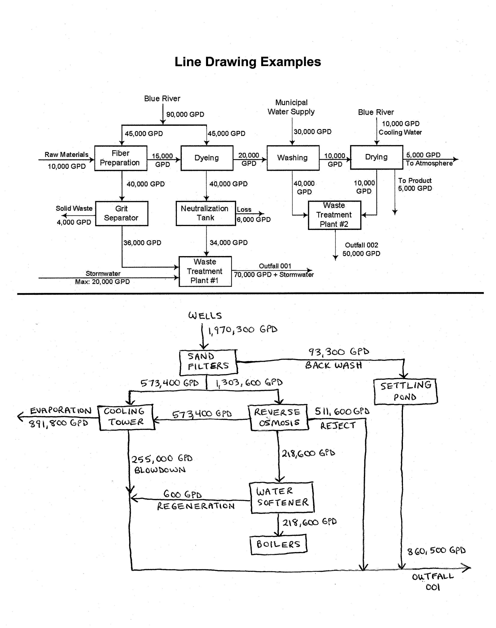

**Figure 1**