INSTRUCTIONS FOR USING THE IOWA DOT HMA PLANT REPORT PROGRAM VERSION 3.5.X

Iowa D.O.T. HMA Plant QC Program - 2009 ver. 3.5
By: Danny Steenhard & John Hinrichsen
Project & Mix Information
Info
Daily Sublot & Sampling Locations
Sublots
Daily Tank Stick For Virgin Asphalt Content
Tank
Gmb Gmm Pa - Test Data Screen
Gyratory
Sieve Analysis Worksheet With RAP ( sample # 1 )
Grad 1
Sieve Analysis Worksheet With RAP ( sample # 2 )
Grad 2
Sieve Analysis Worksheet With RAP ( sample # 3 )
Grad 3
Road Core Density & Air Voids & Stationing
Cores
Plant Temperatures
Temps
Daily HMA Plant Report Screen
Report
Film Thickness & VMA
Film VMA
Daily Diary
Dairy
Daily Production Summary
Summary
Data (For copy and paste to Graph Program)
Data
Quality Index based on % of Gmm
GmmQI
Determination Of Asphalt Content By ( Gmm )
Gmm
Export Data to Another Program or Database
Export

The HMA Plant Report Program is a Microsoft Excel spreadsheet workbook that is supplied to the contractor by the Iowa DOT for the purposes of reporting and storing the project data generated during the production of HMA mixtures for projects let under Iowa DOT specifications. The specifications require the contractor to use this software and provide copies of the completed files to the Engineer. Most of the entries in the software are self explanatory, however some explanation of the proper use of the software is necessary. These instructions are intended to provide the information the user needs to efficiently and accurately complete the required documentation.

If the user is not familiar with the use of Microsoft Excel worksheets, the user should review the documentation and instructions for use of the Excel software product. The user also needs to know how to use a mouse to navigate and select items displayed on the screen. When the term “click” is used in these instructions it refers to pressing the left button on the mouse. When entering percentages, enter only the numbers without the “%” sign.

The menu shown above is the first screen in the program. It is intended only to provide an explanation of the function of each of the spreadsheets included in the program and display the version number. Each spreadsheet in the program is named in the right column above and is accessed by clicking on the tab with that name at the bottom of the Excel screen. For example, the spreadsheet used for entering the “Project & Mix Information” is named “Info” and is accessed by clicking on the Info tab (the second tab) as shown in the following example:

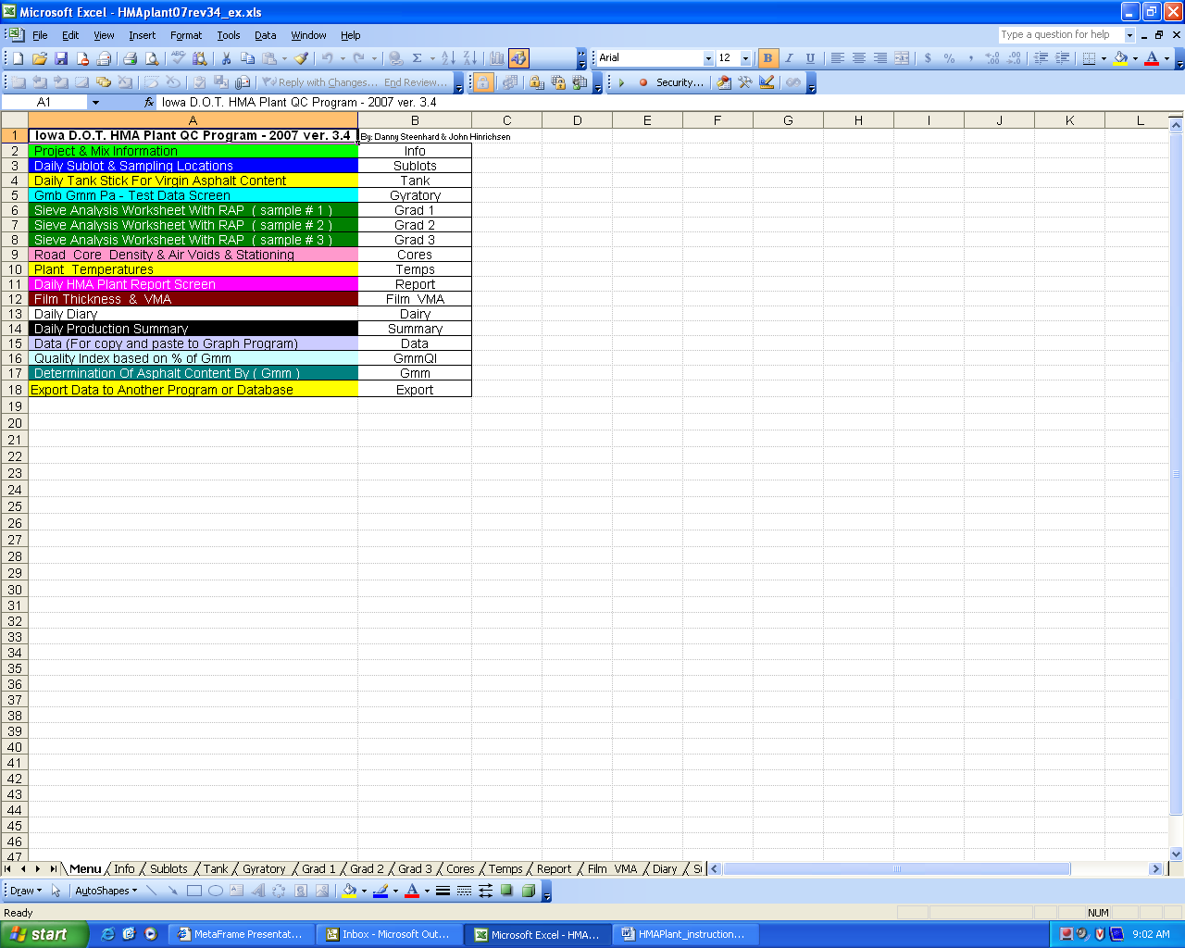
Click
Here
To Access

Clicking on the Info tab brings up the following spreadsheet used for entering the information about the Job Mix Formula (JMF) and the project. The first three entries on this screen: date, report number and the expected tonnage for the day are obviously entries that must be made every day because that information changes daily. The rest of the information on the Info sheet, however, is the basic data on the project, the specifications and the JMF. Most of this information does not change often during the course of production of the HMA mixture. Complete this sheet and save it under a unique name then recall the file every day and enter the daily data on the blank sheets without having to fill in this Info again. Create a file with a completed Info page for each mix design to be used before beginning production. When starting a new day, always recall the file with only the Info page completed, do not attempt to overwrite a previous days completed file. The first thing the user must do, then, is enter all the information shown on the JMF form 956 into the Info sheet beginning with the Mix Design Number cell as indicated by the number 1 arrow. A brief explanation of each entry follows:
1
1

Mix Design Number: This number is found in the upper right corner of form 956 which is often referred to as the JMF or mix design. It is designated “Mix No.:” on form 956.

Target Gradation …: There are eight entries for the gradation targets. The target gradation is shown on form 956. Enter only the target value, the program will then calculate the tolerances, display them to the right of the entries and enter them on the report screen.

% RAP in mix: If RAP is included as an aggregate in the mix on form 956, enter the percentage of RAP shown in the “% in Mix” column on form 956. (Reminder: enter only the number, do not enter a “%” sign when asked to enter a percentage). It is essential that this value be provided in order for the computer to perform proper calculations for mixtures with RAP.

Intended Added % Binder: If there is RAP in the mix, near the bottom of form 956 just above the comments will be a line that shows “The % ADD AC to start the project is” followed by a percentage. Enter the number shown.

Intended Total % Binder: Near the bottom of form 956 is a line titled “Disposition” which will state the total asphalt content recommended to start the project. Enter the asphalt binder content shown. The program will calculate the tolerances, display them to the right of the entry and enter them on the report screen.

% Aggregate No. …: There are cells for entering up to eight aggregate stockpile proportions. Enter the percentage of each aggregate in the mix as shown in the “% in Mix” column in the aggregate area of the form 956. Enter the aggregates in the same order as shown on the form 956. Do not enter the RAP percentage here, enter the RAP percentage as explained above for the “% RAP in mix” entry.

Aggregate No. … Type & Source: There are also eight cells for entering the aggregate sources. The aggregate area of form 956 contains two columns that identify the “Aggregate” and the “Source ID” number. The type of aggregate is listed in the Aggregate column and is typically a simple description such as “sand”, “man. sand”, “3/8 chip” or “1/2 cr. lmst.” The Source ID is a unique identifier number assigned to each quarry or pit approved to provide aggregate to projects as shown in IM T203. The source ID is usually an “A” followed by a five digit number. Sources located in other states will have an abbreviation for the state after the “A” and a three digit number. Enter the type of aggregate followed by the source ID number for each aggregate stockpile in the same order as shown on the form 956. RAP does not have a source ID but is usually identified by the lab number assigned when it was tested in the Central Laboratory, such as ABC7-105.

Cold Feed Sampled By: Enter the name of the certified technician assigned to the task of obtaining aggregate samples from the cold feed belt.

Cold Feed Tested By: Enter the name of the certified technician assigned to the task of performing the sieve analysis gradation of the cold feed sample.

Cold Feed Sampling Location: Enter the point where the cold feed sample is obtained. This is normally either “stream flow” or “stopped belt”.

Project No.: Enter the project number. The project number is a combination of letters and numbers shown on all the contract documents and is also shown at the top of form 956.

Contract ID: Enter the contract ID number. The contract ID number is shown on the contract and is composed of the two digit county number and a dash followed by a four digit route identifier and a dash and then a three digit project identifier.

County: Enter the county identified on the contract. The county is shown on form 956.

Contractor: Enter the name of the Prime Contractor or, if the mix is being produced by a sub-contractor enter the name of the sub.

Target Lab Voids: Enter the target value for lab voids from form 956. The program will calculate the allowable tolerances, display them to the right of the entry and enter them on the report screen.

Mix Type: Enter the type of mix from form 956. For example: “HMA 3M L-3”.

Mix Size: Enter the size of mix shown of form 956. For example: “½ Type A”.

Course Placed: Enter the course or “lift” the mixture is used for. For example: “surface” for a surface course or “inter/surf” if the mixture is used for both the intermediate and surface courses.

Film Thickness Specifications: Enter the range of film thickness allowed by the specifications. The range will be either 8.0-13.0 or 8.0-15.0 depending on the ESAL level of the mix design. The range is 8.0-13.0 for 100K and 300K mixes and 8.0-15.0 for all other mixes.

Filler Bitumen Ratio Specifications: The Filler Bitumen Ratio is currently specified as 0.6-1.4 for all mixtures.

Gsb From 956: Enter the bulk dry specific gravity of the combined aggregate designated as “Gsb” on form 956. Do not enter the G_{sb} value shown in the aggregate area of form 956 for the individual aggregate sources. Enter the G_{sb} shown with the mix data and identified by “Gsb” in the left most column of form 956. It is essential that this value be provided in order for the computer to perform proper calculations.

VMA at Recommended %Binder from 956: Enter the %VMA value from form 956 shown in the bold column of mix data. The program will calculate the tolerances, display them to the right of the entry and enter them on the report screen.

Certified Technician’s Name: There are two cells that are entries to record the certified technician’s name(s).

Certification No.: Enter the certification number for each technician entered. The certification number is shown on the card provided to each technician at the time they are certified/recertified.

% Binder in the RAP: Enter the binder content of the RAP. The RAP binder content is usually on the form 956 in the description of the RAP or in the comments area. This is another value that is essential to be provided in order for the computer to perform proper calculations when RAP is used in the mixture.

RAP Source: Enter what is shown on form 956 as the “Source Location” for the RAP.

RAP Gradation …..: There are twelve cells for entering the extracted gradation of the RAP from the 1 ½” to the #200 sieve. The extracted gradation of the RAP is provided by the Iowa DOT Central Laboratory to the mix designer and is found on form 955 which shows the Proportion & Production Limits For Aggregates. Enter the percent passing for each sieve size as shown on form 955. When RAP is used in the mixture, all the RAP gradation cells must be completed in order for the computer to perform proper calculations.

There are three additional boxes at the top right of the Info screen. Two of these boxes must be completed in order for the computer to display the information in the proper format. Below is a blow-up of this area of the Info screen with arrows numbered 2 thru 4
to designate where the data is entered.

Desired Units: Place an “X” in the box below the type of units required for the project. Most projects are now let in English units, however the program will default to metric units if there is no “X” in the English box designated by arrow 2.

N-design: Enter the design number of gyrations in the box under “N-design” designated by arrow 3. The design number of gyrations is shown on form 956 in the right most column of the mix data.

Gyratory Correction Factor: Do not enter a value in this cell unless directed to do so by the District Materials Engineer. When it is required to correct the contractor’s gyratory compaction values, the DME will determine the correction and provide the value for entry in the cell designated by arrow 4.

2

3

4

Once all the data is entered on the Info screen, the user should save the file under a unique name such as “NHS-6-surf.xls” to indicate the surface mix on project NHS-6-xxx. Do not overwrite the original blank file. Always keep a copy of the original blank file on hand in case of problems.

Entering Daily Data
Before beginning to enter daily sample and test data, the user should check to be sure that there are no required changes to the data on the Info screen. The intended added % binder and the intended total % binder are values that may change from day to day because the contractor is adjusting to produce mix as close as possible to the target values. The % aggregate for each stockpile and/or the % RAP in the mix may also change occasionally as the contractor adjusts the mixture. When aggregate % changes, the G_{sb} of the aggregate may also need to be adjusted based on the individual G_{sb} values for each aggregate shown on form 956 or form 955. The target values for the gradation may also change if the DME approves them. If changes have been made to any of the proportions or target values, the user should change those values on the Info screen and save the file under a new name so that it can be recalled each day with the new values already entered.

As noted earlier, the first three entries on the Info page are for Today’s Date, Report No. and Expected Tons Produced for the Day. These are the first entries made each day.

Todays Date: Enter the date the mixture is produced.

Report No.: Enter a unique report number. A simple consecutive numbering system is acceptable, but some technicians like to include an abbreviation for the course being laid such as “SU-1” for the first day of surface mixture. This is especially helpful when the plant is often switching between different mixes.

Expected Tons Produced for the Day: Enter the contractor’s anticipated plant production for the day. This number is used by the agency’s inspectors to determine preliminary sample locations for the day.

Sublots:
Clicking on the “Sublots” tab brings up the following screen. Four entries are available on the sublots screen to identify when each HMA sample was taken. This information is usually written right on the box of mixture or on a sample ID form sent with the sample. Enter the approximate starting tonnage where each sample was taken as designated by arrow 6.

6

Tank:
Clicking on the “Tank” tab brings up the screen used for determining the amount of asphalt binder used each day. Information can be entered from tank stick readings, asphalt meter totalizer readings or batch weight totals. Tank stick readings are the normal values used unless one of the other methods has been approved by the Engineer. There are two types of tank sticks in common use. One type is called the “outage” stick and the other is called a “direct reading” stick. It is important for the user to be sure which type of tank stick information is being supplied. The tank screen also has the ability to handle up to four tanks providing binder to the plant. Contractors seldom use more than one tank at a time, but occasionally additional tanks are used.

Starting Time: Enter the time the tank stick reading was taken before plant production began.

Tank Capacity …: Enter the total capacity of the tank. This information is essential if using an outage stick.

Outage (% of Diameter): If using an outage tank stick, enter the value read from the stick at the top of the tank with the stick just touching the surface of the asphalt binder in the tank. If using a direct reading tank stick do not make an entry in this cell.

Direct Reading …: If using a direct reading tank stick, enter the value from the stick calibration chart that is matched to the stick reading. If using an outage stick do not make an entry in this cell.

Beginning Temp. …: Enter the temperature of the asphalt binder in the tank at the time of the tank stick reading. Tanks must have a visible and accurate temperature display.

This completes the determination of the amount of asphalt binder in the tank before production begins. The program will calculate and display the beginning corrected gallons in the tank. The next step is to record the deliveries of asphalt binder pumped into the tank during the day.

Total Pounds Binder Added During Day: Enter the total net weight of the certified truck tickets for all loads of binder delivered and added to the tank during production.

Pounds/Gallon: Enter weight per gallon of the asphalt binder shown on the certified truck tickets. If this value changes during the day enter the weighted average value.

This completes the determination of the amount of asphalt binder delivered during the day’s production. The program will calculate and display the gallons of binder added. The final step in determining the amount of asphalt binder used is the same as the beginning step; sticking the tank after production ends for the day. The same information is required as above for time, tank capacity, stick reading, and temperature. Once all the ending readings are entered the program calculates and displays the amount of asphalt binder left in the tank after production ended. The program then calculates the total corrected gallons used by adding the beginning gallons to the added gallons and subtracting the ending gallons. This number is then converted to weight and displayed as “Total Pounds of Binder Used”. Two more entries are required so that the computer can calculate the pay quantities.

Total Pounds Of Mix Made: Enter the total of the net weights of mixture from all truck loads of mix from the plant that day, including any mix that was not incorporated into the project.

Total Pounds Of Mix Wasted: Enter the total amount of mix produced that was not incorporated into the project. This would include mix diverted to other work, rejected loads and any mix left over after construction of the run-out at the end of the day.

7
8
9

Once all the tank stick and mix production values are entered, the program will calculate and display the pay quantities for asphalt binder as “Net Tons Of Binder Used On Road” and HMA mixture as “Net Tons Of Mix Used On Road”. It will also calculate the percent of binder in the mix for comparison to the target value and allowed tolerances.

There are three boxes in the lower right corner of the tank screen. The first box indicated by arrow 7 must always be entered in order for the computer to calculate properly.

Asphalt Binder Sp. Gr. (Gb): Enter the specific gravity of the asphalt binder at 77° F in the box indicated by arrow 7. The specific gravity is shown on the certified truck ticket that accompanies each load of asphalt.

Total Pounds Of Binder Used By FlowMeter or Batch Totals: If the Engineer has approved using the totalizer printout from the calibrated flow meter on a drum mix plant or the total binder determined by adding up the binder weight printed out for each batch in a batch plant, the total value is entered here as indicated by arrow 8. Do not place an entry in this box if tank sticks are being used for binder quantity determination.

Tons of Dry RAP Used (Totalizer): Enter the totalizer value corrected to dry weight for the amount of RAP delivered to the mixer from the totalizer printout at the end of production for the day in the box indicated by arrow 9. If the RAP is not weighed on a weigh belt, as may be the case in a batch plant, this value may be calculated from the batch weights or from percent of total production. This value must be provided in order for the program to calculate the combined gradation, film thickness, filler/bitumen ratio and binder pay quantity when RAP is used in the mix.

Gyratory:
Clicking on the “Gyratory” tab brings up the testing screen for determining G_{mb} (also called “lab density”) and G_{mm} (also called “maximum specific gravity” or “Rice value”). Some of the information on this screen is transferred from the Info screen and Sublots screen.

10

There are spaces for entering up to four samples on this screen designated by “Test 1” thru “Test 4” at the top of the screen. It may be necessary to scroll right on the screen to see all entries. Two columns of data entry cells are assigned to each test to accommodate the two gyratory specimens required for each test.

Hot Box ID Number: Enter the identification number assigned to the field sample. This ID is normally an abbreviation for the course being laid (such as “SU” for surface, “IN” for intermediate or “BA” for base) followed by the month and day separated by a dash and then an “A”, “B”, “C” or “D” to designate the first, second, third or fourth sample of the day.

Hot Box Sample Tons: This cell is filled in by the program from the data entered on the Sublots screen.

Time: Enter the time the sample was taken. This information should accompany the sample.

Station: Enter the station where the sample was taken. This information should accompany the sample.

Side: Enter the direction and/or lane where the sample was taken. This information should accompany the sample.

Compaction Temp….: Enter the temperature at which the gyratory specimens were compacted. This is normally 275 degrees F., but could be changed if the asphalt binder supplier recommends a different temperature and the DME approves.

Specimen ID No: Enter the identification number assigned to the specimen. Each specimen compacted in the gyratory compactor must have a unique identifier, just using “1” for the first specimen every day is not unique. Specimens may be numbered sequentially through the entire project, but the preferred system is to use the report number and a sequential number for that day such as SU-1-1 for the first specimen compacted on the first day of surface mix.

Design No. of Gyrations: This cell is filled in by the program from the data entered on the Info screen.

“W1”, Mass In Air: Enter the weight of the gyratory specimen in air to the nearest 0.1 gram as per IM 321.

“W2”, Mass In Water: Enter the weight of the gyratory specimen submerged in water to the nearest 0.1 gram as per IM 321.

“W3”, Mass SSD: Enter the weight of the gyratory specimen after patting the surface dry to the nearest 0.1 gram as per IM 321.

Gyratory Height @ N Initial: Enter the height of the gyratory specimen as recorded by the compactor at the initial number of gyrations. The initial number of gyrations (N initial) is shown on form 956 in the far right column of mix data.

Gyratory Height @ N Design: Enter the height of the gyratory specimen as recorded by the compactor at the design number of gyrations. N design gyrations was previously entered on the Info screen.

Gyratory Height @ N Max (Optional): Enter the height of the gyratory specimen as recorded by the compactor at the maximum number of gyrations. N max is the final gyration recorded. The Iowa test procedures require that the specimen be compacted to N max and this entry is not optional at this time, it is required.

This completes the entries for one specimen for determination of G_{mb}. Two specimens must be tested for each sample. The program then calculates the measured density, the height ratio and corrected density at N design, and then displays the average corrected density of the two specimens.

Just below the cells for entering the G_{mb} test data is the area for entering the G_{mm} test data for each sample. One G_{mm} test must be performed on each sublot sample.

Pycnometer No.: Enter the pycnometer number assigned to the pyc being used for the test. Every pycnometer is individually calibrated and the calibrations are not interchangeable, so it is important to record which pyc is used.

Mass; Container & Sample: There are several methods that can be used for determining the original mass of the test sample. The preferred method is to tare the pycnometer on the scale, remove the pyc from the scale and place the sample into the pyc, then return the pyc and sample to the scale and directly read the weight of the sample. This is the method used by the Iowa DOT Laboratories. When this method is used, enter the weight of the sample to the nearest 0.1 gram in this cell.

Another method is to weigh the pan containing the sample, place the sample in the pyc, then weigh the empty pan and determine the weight of the sample by subtracting the empty pan weight from the weight of the pan with the sample in it. If this method is used, enter the weight of the pan with the sample in it to the nearest 0.1 gram.

Mass, Container: If using the preferred method described above, do not make an entry in this cell indicated by arrow 10. If using the other method, enter the weight of the empty pan after placing the test sample into the pyc. The technician may also weigh the empty pyc and enter the weight here then place the sample in the pyc and record the total weight and enter it in the “Mass; Container & Sample” cell so the program can determine the sample weight by subtraction.

“W”, Sample Mass: The program will transfer the weight of the sample from the Mass; Container & Sample cell if using the preferred method. If using the other methods, the program will do the subtraction and display the result as the sample mass.

“W1”, Mass Pyc. & H20 @ Test Temp.: Enter the weight of the pycnometer filled with water from the calibration chart for that pyc that corresponds to the temperature determined at the end of the test as per IM 350.

Total Mass: The program will add W + W1 and display the result in this cell.

“W2”, Mass Pyc. & Water & Sample: Enter the final weight of the pycnometer with the sample inside and completely filled with water after completion of the 15 min. vacuum and 10 min. rest periods as per IM 350.

Mass Displaced Water: The program will subtract W2 from the total mass and display the result in this cell.

Test Temperature Of Water…: Enter the temperature of the water in the pycnometer at the completion of the test to the nearest 0.5 degree as per IM 350.

R Multiplier (chart): The program will look up the appropriate correction factor for temperature (referred to as the R multiplier) and display it in this cell.

(Gmm): The program will calculate the maximum specific gravity of the mix (G_{mm}) and display it in this cell.

Pa – Test Data: Once all the information needed for determination of G_{mb} and G_{mm} has been entered, the program will calculate the percent air voids in the gyratory compacted specimens and display it in this cell.

Below the air voids value are three more lines of information displayed by the program: Gyratory Slope, Average Slope, and % G_{mm} @ N ini. & N max. This data is for information only and is related to the mix design. These values may be of interest to the Quality Control Technician, as a sudden change in these values may indicate changes in the mixture volumetrics.

Grad 1:
There are three tabs labeled “Grad 1”, “Grad 2” and “Grad 3” for entering gradation test data. All three screens work the same. The sample weights and weights of material retained on each sieve are entered on this screen and the program calculates the combined gradation. Data may be entered from a gradation performed on twelve inch sieves using the total sample, or from a gradation performed on eight inch sieves using a reduced minus #4 sample portion as per IM 302. The green colored cells are to be used only if the reduced minus #4 sample test method is used.

12

11

12

Lab No.: Enter the lab number assigned to the aggregate sample. Use a unique identifier for each sample.

Orig. Dry Mass: Enter the original dry weight of the sample to the nearest 0.1 gram as per IM 306.

Dry Mass Washed: Enter the dry weight of the sample after washing over a #200 sieve to the nearest 0.1 gram as per IM 306.

Total Minus #4 (W1): Do not make an entry in the green cells indicated by arrow 11 if the total minus #4 portion of the sample is sieved. If using the reduced minus #4 testing method as per IM 302, enter the total amount of minus #4 material left after performing the coarse portion of the sieve analysis to the nearest 0.1 gram.

Reduced Minus #4 (W2): If using the reduced minus #4 testing method as per IM 302, enter the amount of minus #4 material left after reducing the fine portion of the sample to the nearest 0.1 gram. This is the amount of material actually placed in the fine sieves.

Conversion Factor: The program will calculate the ratio of the reduced minus #4 portion to the total minus #4 and display it in this cell.

Individual sieve entries:
There are two columns of cells that may be used for entering the weights retained on each sieve. Notice that for the coarse portion of the sieve analysis (1 ½ inch thru the #4 sieve) only yellow cells under “Total or Calc. Mass Retd.” are available for input. Enter the weight retained on each sieve that retained any material to the nearest 0.1 gram.

For the #8 thru the pan, use the green colored cells indicated by arrow 12 only if using the reduced minus #4 sample test method as per IM 302. If sieving the total minus #4, use only the yellow cells. Enter the weight retained on each sieve to the nearest 0.1 gram.

Once all the weights have been entered, the program will calculate the cold-feed gradation and display the results. If the mix contains RAP, the RAP totalizer reading and total amounts of binder and mix must be entered on the Tank screen before the program will calculate and display the combined gradation including the RAP.

For convenience, the specified tolerances for each sieve are transferred from the Info screen and placed in the far right column on the gradation screens.

Cores:
Clicking on the “Cores” tab brings up the screen for entering the data on the cores and the placement stationing. The core data is supplied by the agency’s inspector who performs the density and thickness testing of the cores.

Density Record: Seven columns of input cells are provided for entering the location and test data on each core.

Station: Enter the station to the nearest foot where the core was sampled.

CL Reference: Enter the offset from the center line to the nearest 0.1 foot where the core was sampled.

W1 Dry: Enter the original dry weight of the core to the nearest 0.1 gram as per IM 321.

W2 in H2O: Enter the weight of the core submerged in water to the nearest 0.1 gram as per IM 321.

W3 Wet: Enter the final weight of the core after the surface is patted dry to the nearest 0.1 gram as per IM 321.

Thickness…: Enter the average of four measurements of the core to the nearest 1/8 inch as per IM 337. Entries can be made as fractions or decimals.

Date Tested: Enter the date the cores were tested. This is often the day after the mix was produced and placed.

Intended Lift Thickness: Enter the design lift thickness for the course from which the cores were sampled. The intended lift thickness is shown on the plans.

Tested By: Enter the name of the certified technician who tested the cores.

Required Density: Enter the applicable density requirement for the lift from which the cores were sampled. This will be 94, 95 or 96 depending on the location and type of project. The class of compaction is normally shown on the plans and is explained in the specification 2303.03.

Placement Record: Five rows of cells are provided for entering the stationing that defines the area where the mix was placed. When equations or other breaks in stationing occur each area of continuous stations should be entered separately.

From Station: Enter the beginning station of each section or area placed.

To Station: Enter the ending station of each section or area placed.

Lane: Enter the direction and/or lane for each section or area placed.

Below the placement record is an area marked “Information Only”. Once all the data is provided for the cores, and the test data for G_{mb} and G_{mm} has been entered on the Gyratory tab, the program will calculate the percent of lab density and percent voids for each core and display it here.

Temps:
Clicking on the “Temps” tab brings up the screen where the temperatures of the air, binder and mix are entered. Temperatures must be obtained at two hour intervals during production.

Air Temp….: Enter the temperature in the shade at the plant site.

Binder Temp….: Enter temperature of the asphalt binder in the tank being used.

Mix Temp….: Enter the temperature of the mixture as discharged from the plant into the truck. This temperature is normally obtained by checking the temperature of the mass of material in the loaded truck.

Mat Temp….: Enter the temperature of the mat obtained behind the laydown machine. This information is relayed back to the plant from personnel at the placement operation.

Report:
Clicking on the “Report” tab brings up the screen that summarizes the daily production and quality control data. This report must be completed and sent to the DME within four hours after beginning plant production on the next working day. Most of the information shown on the Report screen is transferred from the other screens, however there are a few entries that the user must make to complete the report. The entries that must be made on the report are the moving averages, gradation compliance, production tonnage, mix changes, and any remarks. There is also an area on the report where the user may enter the District Lab test data. The DME may require the District Lab test data to be on the report. This is especially important when there are test validation issues between the District Lab and the contractor’s QC lab.

The following example shows the left half of the report screen. Because this program is a daily spreadsheet it cannot look back at the previous day’s data that is needed to calculate moving averages. The user must calculate and enter the moving average of the current test with the previous three test results (always the last four available test results).

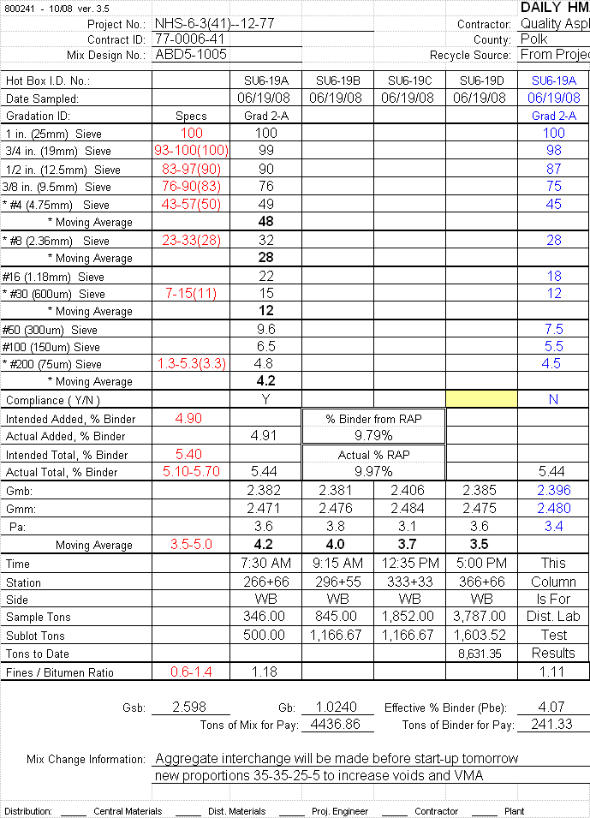
17
13
14
15
16

16
18

* Moving Average: Arrow 13 designates the first of four moving average entries required for the gradation (shown in bold). There is a moving average entry required for the four sieves: #4, #8, #30 and #200. As soon as four gradation tests have been completed for the mix, begin calculating the moving average of four tests and continue to calculate a new moving average for each new test added. Enter the moving averages of the gradation for the four sieves designated by * in the rows designated by “* Moving Average”.

Compliance (Y/N): Enter a “Y” or a “N” in the cell designated by arrow 14 to indicate whether the gradation was within specification limits or not. If more than one official gradation is run, make an entry for compliance for each gradation.

Notice there is a yellow colored cell in the next to last column of mix data on the Compliance line. This cell is used for averaging the daily gradations when more than one official gradation is performed for a lot. If two gradations have been recorded enter a “2” in the yellow cell and if three gradations have been recorded enter a “3”. The program will then average the gradations and display the results in the column above the yellow cell. Do not make an entry in this cell unless more than one gradation has been entered into the program.

Moving Average: Arrow 15 designates the area where the user must enter the moving average of laboratory air voids (P_{a}). As soon as four G_{mb} and G_{mm} tests have been completed for the mix, begin calculating the moving average of four P_{a} values and continue to calculate a new moving average for each new test added. Enter the moving average of P_{a} after each test in the row designated by “Moving Average”.

Tons to Date: Arrow 16 designates the entry for the cumulative tonnage of the mix. Enter the running total of mixture incorporated (pay quantity) for the course(s) being constructed with this mix.

This Column Is For Dist. Lab Test Results: The far right column of the mix data designated by arrow 17 is for entering the test results produced by the District Laboratory on the paired or split samples for the lot being reported. Data entered in this area should correspond to the sample(s) tested and reported by the contractor on the same report.

Enter the HMA and cold-feed sample ID numbers and the date sampled at the top of the column. Enter the aggregate gradation but do not include in the moving averages. Enter a compliance Y/N for the District Lab gradation. Enter the District Lab G_{mb}, G_{mm} and P_{a} results on the HMA sample but do not include in the moving average. This data is normally for information only, but may be used as the acceptance test values under certain circumstances.

There may be instances where the contractor’s average test data is entered for some of the cells in the Dist. Lab column. More information on this will be presented in the instructions for use of the “D.O.T. Results Used” cell in the next section.

Mix Change Information: Arrow 18 designates the area where any adjustments to the mix proportions are recorded. Any changes to the aggregate proportions or asphalt binder content must be recorded here along with the time the change took effect.

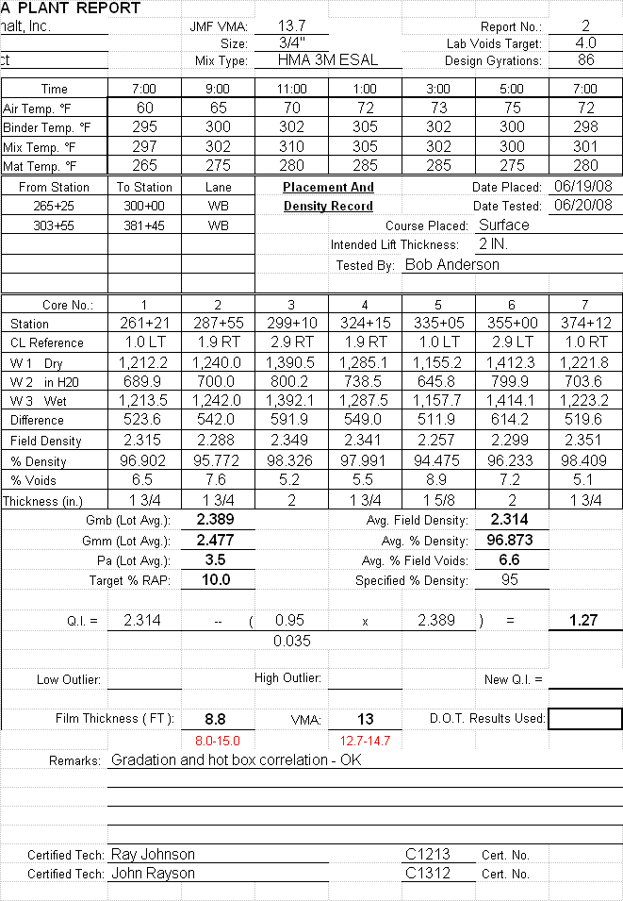
19
20
21

Above is an example of the right half of the report screen. Only two entries are allowed here, the rest of the information shown is transferred from other screens or calculated from previously entered data.

Remarks: Arrow 19 designates the area the user may enter any comments that apply to the days work.

D.O.T. Results Used: The box designated by arrow 20 is to be used only when instructed to do so by the DME. Placing an “X” in this box causes the program to use the data supplied in the Dist. Lab Test Results column discussed above, and ignore the contractor’s data. This is normally only done when the District Lab is unable to validate the contractor’s test results as detailed in IM 511. There are several scenarios in which the Dist Lab Test Results column would be used.

If, for some reason, all of the contractor’s test results are considered invalid for the lot, then enter all the District Lab test results in the column designated by arrow 17. This would occur, for example, if the contractor’s lab was not qualified, or the technicians were not properly certified. Enter an “X” in the box designated by arrow 20 to force the program to use the Dist. Lab results.

If only one test result is not validated, the contractor’s test results for the other tests that have been validated should be entered into the Dist. Lab column and only the Dist. Lab result for the test in question should be entered there. For example, if the District Lab does not correlate on the G_{mm} test two days in a row, but has correlated on all other tests, the entries in the Dist. Lab Test Results column would be: the contractor’s gradation (or average gradation if more than one on the lot), the contractor’s lot average G_{mb}, and the Dist. Lab’s G_{mm}. Then when an “X” is placed in the box the program will use the contractor’s data for gradation and G_{mb} and the Dist. Lab data for G_{mm} to calculate the required values. Indicate in the remarks which test data was used.

The QI, Low Outlier, High outlier, and New QI values are calculated from the mix data and core data entered previously. Arrow 21 designates the area of the report where the QI values are shown. If the QI result is 0.72 or less the program will check for low and high outliers and display the results in the cells for each calculation. If one of the outlier values is 1.80 or greater, the program will then eliminate the outlier from the data set and recalculate the QI and display it in the New QI cell. If neither outlier value is 1.80 or greater, the program will not calculate a New QI and the original QI value is used. If there is a value shown in the New QI cell, it is the value used for determining pay as per Standard Specification 2303.06, unless the New QI value is less than the original QI value.

Film VMA:
Clicking on the “Film VMA” tab brings up a screen that displays the entire calculation of the film thickness and VMA values. No data is input on this screen, it is for information only.

Diary:
Clicking on the “Diary” tab brings up a screen where the user may enter the weather conditions and document any significant events that occurred that day.

Sunrise: Enter the sunrise time for the day.

Sunset: Enter the sunset time for the day.

Low: Enter the low temperature for the day. The program will display the high temperature from the entries on the Temp screen.

Weather: Enter a description of the day’s weather.

The rest of the Diary page is for recording significant events that occurred that day, such as interruptions to production, breakdowns, rain delays, material delivery changes, equipment changes, instructions issued by the Engineer, etc. Anything that the technician feels may be important to document should be placed in the diary.

Summary:
Clicking on the “Summary” tab brings up the daily production summary screen that displays the quantities of materials used that day and the stationing placed. There are no entries made on this screen, it is for information only. This page documents the pay quantities for asphalt binder and HMA mixture. This page also documents the estimated amount of each aggregate stockpile used that day. This information is valuable to the technician for tracking the amounts of materials used for comparison to the quantities certified.

Data:
Clicking on the “Data” tab brings up the screen used for a copy and paste function to transfer data to the charting program. The Iowa DOT provides another Excel spreadsheet workbook that produces the QC charts from the data entered or pasted from this plant report program.

22

23

24

All of the information on the Data screen is transferred from the Report screen. The user must have both this plant report program and the QC charting program loaded into Excel so that each program can be brought to the front of the screen as needed. The user must do three separate copy commands and paste special commands in order to transfer all the data from this screen to the charting program. The first copy command is made for the information designated by arrow 22. Highlight the date and asphalt content shown then click on the copy icon in the tool bar or click on edit then copy from the Excel menu at the top left portion of the screen. Do not highlight the headings in the blue colored cells, only the data displayed below them. Highlighting is accomplished by pointing the mouse at the first cell then holding down the left mouse button and moving to the last cell before releasing the button. The charting program is then brought to the front of the screen by clicking on the file name at the bottom of the screen or clicking on “Window” at the top of the screen then clicking on the file name. The user then needs to click on the “Data” tab in the charting program and click on the first blank date cell under “% Asphalt”. Finally, the user must select “File” from the Excel menu at the top left of the screen, then select “Paste Special” then select “Values” then select “OK” and the data should be copied. If any error occurs, simply click “File” and select “Undo Paste Special” to return the screen to the way it was. More detailed information for pasting data into the charting program is provided in the Instructions for use of the QC Charting Program.

Next, return to the Plant Report Program and highlight the information in the box designated by arrow 23. Highlight the dates, G_{mb}’s and G_{mm}’s then click on copy. Up to four lines of data may be copied at once. Follow the same procedures as above for pasting the data into the “HMA Test Data” columns of the charting program.

The gradation data designated by arrow 24 is the final information copied from this screen and transferred to the charting program. Highlight the date and the percent passing data for the four screens then copy it. Up to three lines of data may be copied at once.
Paste it into the gradation data area of the charting program as explained above.

GmmQI:
Clicking on the “Gmm QI” tab brings up a screen that displays the core densities and two calculated quality indexes based on the percent of G_{mm} rather than the percent of G_{mb}.

25

No information is entered on this screen, the data is transferred from the Report screen. The core density data in the box designated by arrow 25 can be copied and pasted into the charting program in the same manner as the information on the Data screen detailed above. The G_{mm} QI’s shown on this screen are for information relating to the use of this calculation.

Gmm:
Clicking on the “Gmm” tab brings up a screen where the asphalt binder content is calculated for each HMA sample based on the G_{mm} value determined for that sample. No entries are made on this screen, it is for information only. This information is valuable to the technician because it may indicate asphalt content variations in the plant production that are not visible in the tank stick data.

Export:
Clicking on the “Export” tab brings up a screen that contains one long line of data extracted from the other screens. This data must also be pasted into the QC charting program. This screen contains a Macro that will automatically copy the data.

26

To use the macro to copy the data, simply click on the large text “Export Data” in the middle of the screen as designated by arrow 26. This will highlight and copy the entire line of data from column A to column IS. If the computer being used does not allow the use of macros due to being set for high security, the user can still copy the data and paste it into the charting program. One method is to reset the Excel security to medium or low to allow the use of macros. This is done by selecting “Tools” and “Options” then selecting the security tab and clicking on the “macro security” button and selecting medium or low security. The user will need to exit the Excel program and reload it for the change in macro security to take effect. If for some reason the user is not authorized to change the macro security it is still possible to copy and paste the data, but the copy must be done by using the mouse to highlight all of line 3 on the Export screen from column A and scrolling several screens to the right all the way to column IS. If manually copying, it is important to highlight the entire line 3 from column A to IS then click on copy.

Once the data on line 3 has been copied either by the macro or manually, it must be pasted into the Charting program. Bring the Charting program to the front by clicking on the file name at the bottom of the screen then clicking on the “Import” tab. Click on the first empty cell in column A under “Date” then paste the same way as the other data, by selecting “Edit” from the menu at the top of the screen, then selecting “Paste Special” then “Values” then “OK”. Exporting the data to the charting program is the last step that must be done once all the data has been entered into the Plant Report program and checked for accuracy.

More detailed information for pasting data into the charting program is provided in the Instructions for use of the QC Charting Program.

